Section 3:
From the September earthquake to the February earthquake

3.1 The Canterbury earthquakes

The Royal Commission has conducted investigations into the nature and characteristics of the Canterbury earthquakes, with a particular focus on the earthquakes on 4 September 2010, 26 December 2010, 22 February 2011 and 13 June 2011. Submissions were invited on the issue of seismicity, which was addressed in a hearing in October 2011.

Section 2 of Volume 1 describes the nature and severity of the earthquakes. As stated in section 2.7.1.1 of that section, the peak ground accelerations in central Christchurch during the September earthquake were close to those that would have been used to design new buildings under the current Earthquake Actions Standard, NZS 1170.5:20041. With some qualifications (which are stated in that section of the Report), the shaking experienced in the Christchurch Central Business District (CBD) was generally comparable to that anticipated for a 500-year return period earthquake on the Class D soils that are found there.

Dr Brendon Bradley, who is a lecturer at Canterbury University and has a seismic engineering consultancy, was called by Dr Reay and ARCL to give evidence about the ground motions associated with the earthquakes. He had earlier provided a report at the request of the Royal Commission, Ground Motion and Seismicity Aspects of the 4 September 2010 Darfield and 22 February 2011 Christchurch Earthquakes: Technical Paper prepared for the Canterbury Earthquakes Royal Commission2. The Royal Commission’s consideration of the failure of the CTV building has been against the background of all of the reports and evidence received in relation to seismicity and discussed in Volume 1 section 2 as well as Dr Bradley’s evidence in the CTV hearing. This is discussed in section 5.4.4.

3.2 The September earthquake

REHS

CBGS

C

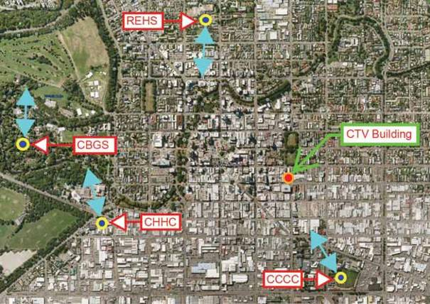Figure 31: Location of seismic measuring stations and predominant direction of ground accelerations at the site of each location in the September earthquake. The location of the CTV site is also shown

On 4 September 2010, at 4:35am, an earthquake

of 7.1M
w
struck Christchurch and the surrounding
Canterbury region. Its epicentre was about 40km west of Christchurch on a previously unknown fault beneath the Canterbury Plains. GNS Science advised in its report that this was a rare event that had occurred in an area where previous seismic activity was relatively low for New Zealand.

3.3 Observations of damage between the September and Boxing Day earthquakes

The Royal Commission heard evidence from a number of witnesses about their observations of damage to the CTV building after the September earthquake. As explained in section 1, the first two levels of the building were occupied by CTV. A number of CTV staff gave evidence. Mr Peter Brown worked as a technical engineer until he retired in December 2010. Ms Penelope Spencer was a production assistant. Mr Tom Hawker was a Presentation Director whose desk was located in the presentation room which was approximately in the centre of level 2. Mr Malcolm Harris, who sat adjacent to the western wall on level 2, was a Sales Manager. Mr Simon Thomas was an Account Manager whose desk was in the south-western corner of level 2.

King’s Education occupied level 4. Ms Margaret Aydon joined as Operational Manager in October 2010. Her office was near the lifts. Mr Ron Godkin, who was a tutor in healthcare, was also the Health and Safety Officer for King’s Education. Ms Marie-Claire Brehaut carried out administration duties, design work and course development.

Ms Phillippa Lee was the sole survivor from The Clinic, which was on level 5. She was a receptionist and her desk was in the reception area in the north-east corner of that level.

Ms Elizabeth Cammock is a counsellor with Relationship Services (now Relationships Aotearoa), which occupied part of level 6. Ms Nilgun Kulpe worked as a counsellor since 2007. Her office was adjacent to the western wall.

3.3.1 Level 1

South wall

Both Mr Brown and Ms Spencer described damage to the plasterboard along the south wall of Level 1 by the fire escape. Mr Brown recalled a crack in the wall of the master control room, which was adjacent to the south shear wall. The crack was approximately two metres in length and ran vertically from the ceiling nearly to the floor. It could be seen from the outside. Ms Spencer described numerous cracks in this room, referring in particular to a diagonal crack that ran up the south wall about 50cm in length. Mr Hawker also recalled a crack in the south wall of the master control room. He described it as a jagged, diagonal crack about one metre long. Although he marked the room on his
floor plan as an internal room rather than along the shear wall it is likely the position of this room in his plan is incorrect and this is the same crack referred to by Mr Brown and Ms Spencer.

North wall

Mr Brown said cracks approximately two metres in length appeared in the northern wall of the carpark along the join where the concrete blocks met the ceiling. He was not sure what caused the cracks but wondered whether they were a result of aftershocks. He said they appeared to get worse over time.

3.3.2 Level 2

Western wall

Mr Harris, Mr Thomas and Mr Brown all referred to damage along the western wall. Mr Harris said there were approximately 15 to 20 very noticeable cracks running roughly from floor to ceiling. He said daylight could be seen through some of them. Mr Thomas and Mr Brown both recalled two cracks in the western wall: one ran alongside a pillar, the other was in the south- western corner. Mr Brown confirmed the cracks were in the structural wall rather than plasterboard. Both cracks ran from close to the roof to around the middle of the wall and appeared to increase in size with each aftershock. Mr Brown said more and more daylight could be seen through the crack alongside the pillar. Mr Brown photographed this crack.

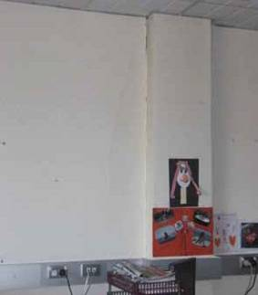

Figure 32: Vertical crack alongside pillar on western wall of level 2 (source: Peter Brown)

South wall

Mr Harris recalled that cracks appeared in the office of Ms Joanne (Jo) Giles, a CTV host. These were described as “numerous” and ran from floor to ceiling along the southern wall. Ms Giles would mark the cracks with a felt pen and add to the number as new ones appeared.

North wall

Mr Brown photographed two cracks in the north wall near the stair well. One ran vertically up the plasterboard under the ceiling and was about 600mm in length. The other ran vertically from the ceiling about a metre in length and joined the horizontal crack at the ceiling.

Figure 33: Two cracks in the north wall near the stair well on level 2 (source: Peter Brown)

Mr Brown described another crack between one of the pillars and the wall in the north-west corner of the building which ran from floor to ceiling. He said it would have been about 25mm wide after the September earthquake. He could see daylight through the whole crack. He was told by colleagues that it increased slightly in size between September and December.

Eastern wall

Mr Brown, Mr Thomas and Ms Spencer recalled areas of cracked glass along the eastern wall. The cracks deteriorated with each aftershock. Mr Brown put “gaffer” tape across them hoping that this would help keep the window pane together. The windows were eventually all replaced. Mr Brown photographed the replacement of one of them.

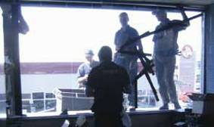

Figure 34: Replacement of a cracked window in the eastern wall on level 2 (source: Peter Brown)

Internal

Mr Brown photographed a horizontal crack that appeared along the ceiling in the north-eastern end of the building. It was approximately 2m in length and 4mm wide. He said it appeared as though the ceiling had been forced down because it could be seen that the plaster board had compressed by about 4mm.

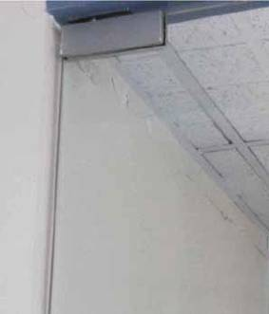

Figure 35: Horizontal crack along the ceiling at the north-eastern end of level 2 (source: Peter Brown)

Mr Brown and Ms Spencer recalled two vertical cracks that appeared in an internal wall at the north-eastern end of the building. Mr Brown photographed the cracks.

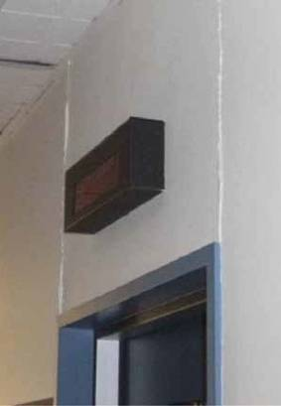

Figure 36: Two vertical cracks in an internal wall in the north-eastern end of level (source: Peter Brown)

3.3.3 Level 4

Internal

Ms Margaret Aydon, Ms Marie-Claire Brehaut and Mr Ronald Godkin all gave evidence about the appearance of a crack in an internal partitioning wall. Ms Aydon recalled it was approximately 10mm in width, Mr Godkin estimated its width as 50mm and Ms Brehaut said it was about 1mm wide. Ms Aydon said it ran vertically down the pillar, approximately half its length, while Ms Brehaut said it spanned the entire length from the floor to the ceiling. Ms Brehaut said she had always been able to hear muffled voices between the rooms, because the walls were so thin, but when the crack appeared she could hear what was being said in the next room.

Ms Aydon, Ms Brehaut and Mr Godkin recalled that
the floor was not level under the reception desk, which was located opposite the lifts in the vicinity of the beams on line 3. Mr Godkin said a “hump” appeared in the floor following the September earthquake that appeared to get bigger as aftershocks continued. Each gave evidence that whenever a pen was placed on the reception desk it would slowly roll in a south-east direction.

Mr Godkin expressed his concern over the hump to Mr John Drew and the engineer at the time of the second inspection. Mr Godkin said this took place in late September, so he must have been referring to the inspection by Mr David Coatsworth, who carried out inspections at the request of Mr Drew. Mr Godkin said the engineer told him that all concrete buildings “hump” between the supporting beams that hold the floors up when the concrete dries over the support. Mr Godkin recalled the engineer telling him the building was doing what it was meant to do following an earthquake and it was not a problem. Mr Coatsworth gave evidence that he spoke to some of the staff at King’s Education about the “deflections in the floor”. He said he “noticed the high points over the beams and the sags in between but would have expected to have seen more significant deflections if the floor had yielded”.

Ms Aydon and Mr Godkin recalled damage to a glass partition in the canteen on the western side of the floor which had been taped with masking tape to stop it from cracking further. Although Ms Brehaut did not recall the windows were damaged, she confirmed the window partitions were taped.

Western wall

Mr Godkin recalled that a horizontal crack had appeared in the plaster under a window on the western side of the building.

South wall

Ms Aydon, Ms Brehaut and Mr Godkin recalled areas
of damaged glass along the south wall. Mr Godkin said they experienced ongoing damage with the glass along the south wall and anything that was not reinforced cracked quite regularly in the aftershocks. The panes of glass were eventually replaced.

Water leaks

Ms Aydon and Mr Godkin recalled experiencing water leaks on two separate occasions but it is unclear precisely when this occurred. Ms Aydon said the first occasion was probably around the middle of October and the second was some time after Boxing Day. Mr Godkin said the leaks occurred in early to mid- January and just before the February earthquake. On both occasions Mr Drew had the leak fixed. Mr Godkin said he was advised that it was the result of work with the heat pumps on the floor above (level 5).

3.3.4 Level 5

West wall

Ms Phillippa Lee recalled diagonal cracks coming up from the floor along the west wall. The cracks were visible from about three metres away, some spanning approximately one metre in length. Ms Lee said one of her colleagues had put white tape on some of the cracks but the cracks had grown past the tape by about 50mm.

3.3.5 Level 6

North wall complex

Ms Elizabeth Cammock and Ms Nilgun Kulpe noticed cracks on either side of the lifts. The crack on the eastern wall was of particular concern. Ms Kulpe said it ran vertically, on a slight diagonal, above and below the window. It was approximately 1.5m in length.

Several witnesses noticed that one of the columns outside the lifts was cracked. Mr Leonard Pagan photographed the damage as part of a walk through inspection with Mr Drew and Mr Coatsworth.

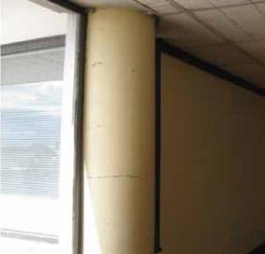

Figure 37: Cracked column C18 outside the lifts on level 6 (source: Leonard Pagan)
3.4 Post-September earthquake rapid assessments

3.4.1 Introduction

A state of local emergency was declared in
Christchurch on 4 September 2010 under section 68
of the Civil Defence Emergency Management Act 2002. The Christchurch City Council (CCC) initiated a civil defence emergency management response. The state of local emergency continued until midday on 16 September.

From 5 September, the CCC sent teams out to undertake Level 1 Rapid Assessments of commercial parts of the CBD. This was an exterior inspection to look for obvious signs of damage, immediate dangers or buildings where further investigations were required. The typical teams of three included at least one CCC officer who was usually accompanied by a structural engineer. There is a detailed discussion of the processes followed in section 2.3.3 of Volume 7 of our Report.

3.4.2 Level 1 Rapid Assessment following the
September earthquake

A Level 1 Rapid Assessment of the CTV building was conducted on the afternoon of 5 September. The inspection team comprised Mr Peter Van der Zee from the CCC, Mr Richard Sullivan who was a Chartered Professional Engineer, a USAR officer who has not been able to be identified and one other person, also unidentified. Mr Van der Zee is a CCC building consent officer who had three years’ experience in that role at the time but no experience in building inspection. He completed a Level 1 Rapid Assessment form after consultation with the others in the team, recording that the estimated overall building damage was “None”. They allocated a green placard and completed a form recording, “No restriction on use or occupancy”. The form noted that the inspection was brief and that no apparent structural or other safety hazards had been found. However, the wording on the green placard encouraged the owner to “obtain a detailed structural engineering assessment of the building as soon as possible”.

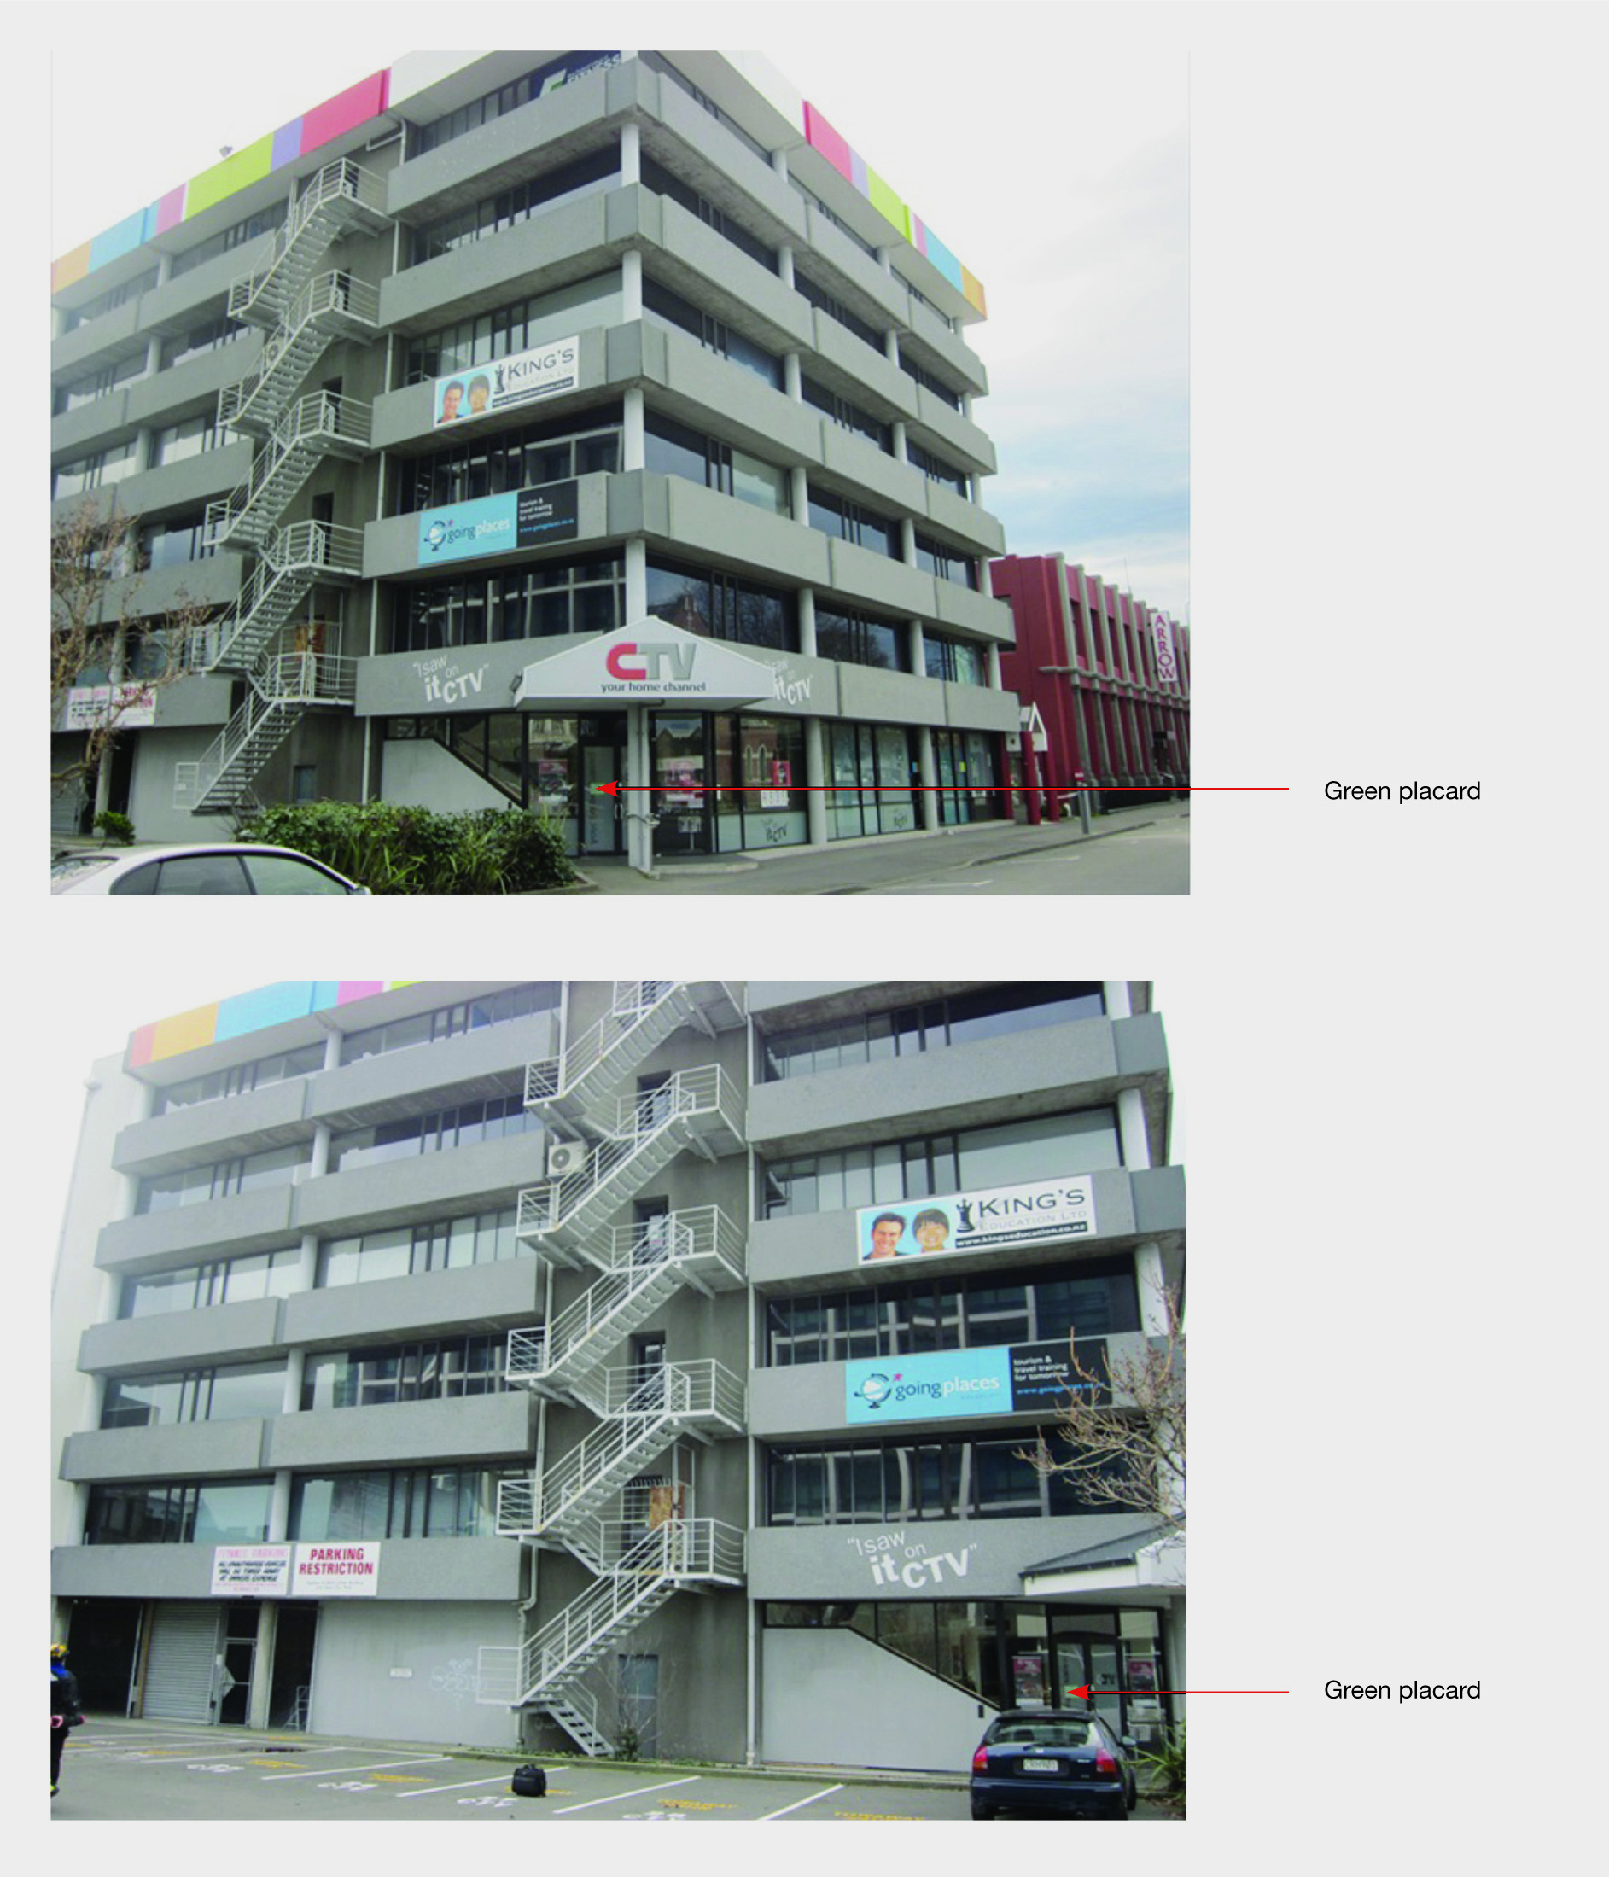

Figure 38: Photographs taken from respectively the south-east and the south of the CTV building by Richard Sullivan on 5 September 2010. The green placard can be seen on the main entrance door

Mr Van der Zee could not remember the inspection of the CTV building and had to rely on the content of the form he completed on 5 September when giving evidence. During cross-examination he said he had no training in post-earthquake building assessments before the September earthquake, nor had the majority of CCC building officers who carried out assessments at that time. However, they received some training after the 4 September earthquake which consisted of morning briefings on 5 September and the days that followed. Mr Van der Zee believed this training was adequate for him to understand the purpose of the Level 1 Rapid Assessments that he was undertaking. He said that training before the earthquake would not have assisted because they were looking for obvious signs of damage and hazards and were not thinking “too much further down the track”. However, he was not aware of the CCC policy about when Level 2 Rapid Assessments were required and relied on the CCC Building Evaluation Team to initiate further action if necessary once they reviewed the Level 1 Rapid Assessment form.

Mr Sullivan did not recall details of the inspection other than that the team looked at the east and south elevations of the building, as shown in his photographs, and that they approved the allocation of a green placard.

We discuss the process used to determine when a building would receive a Level 2 Rapid Assessment in section 2.3.3.2.2 of Volume 7.

3.4.3 Level 2 Rapid Assessment on 7 September Mr Stephen McCarthy was one of the Building Evaluation Managers in the Christchurch City Emergency Operations Centre during the state of emergency. On 7 September, he asked three CCC building officers to undertake assessments on three buildings urgently, one of which was the CTV building. The three officers were Mr David Flewellen, a senior building inspector with 26 years’ experience, Mr Russell Simson, a building consent officer with 18 years’ experience (12 of which were as a building inspector), and Mr Graham Calvert, a senior building support officer who primarily dealt with weathertight home claims against the CCC, but who also had two or three years’ experience as a building inspector for the CCC and three years’ experience as a residential building inspector working for a Building Certifier. Mr Flewellen, Mr Simson and Mr Calvert were each separately represented at the Royal Commission hearing.
Mr McCarthy was responsible for assigning groups to inspect buildings in a specific area. He said that occasionally a request would come in to inspect a specific property. Although Mr McCarthy was unable to recall details he confirmed that the CCC had received a request to inspect the CTV building. He speculated that the request may have come from the building manager or owner.

It is not certain what instructions were given to
Mr Flewellen, Mr Simson and Mr Calvert and whether they were being directed to carry out a Level 1 or Level 2 Rapid Assessment or something different. Mr Flewellen recalled Mr McCarthy explaining to him that there was an urgent need to assess three particular buildings, the CTV building being one of them. He said it was implicit in what Mr McCarthy said that, despite the unavailability of an engineer, he was confident that the three officials had sufficient experience to conduct the rapid assessments themselves. Mr Flewellen said there was really no choice but to conduct those rapid assessments if they were to be done at all.

Initially Mr McCarthy could not recall the events surrounding the assessment but was reminded after reading Mr Flewellen’s evidence. With this assistance, Mr McCarthy remembered sending the three officials out to inspect buildings, although he could not remember assigning them to the CTV building specifically. He said the request came in after all available engineers had been dispatched elsewhere. However, he was confident he would have told the three officials that engineers were available and if necessary one could be sent to the building later that day. He recalled telling Mr Flewellen that if there were any issues then they should request that an engineer inspect the building.

Justice Cooper put to Mr McCarthy that, because no engineer was available, he must have been sending the three officials out to undertake a Level 1 Rapid Assessment. Mr McCarthy said it was likely they were being sent out to give advice to the owner of the buildings about their responsibilities and it may not have been necessary for them to do an assessment at all. He suggested that the main outcome of their visit was that they advised the owner to engage an engineer.

After carrying out external inspections on the other two buildings, the CCC officers arrived at the CTV building to find that a green placard had already been placed on the building. Neither Mr Flewellen nor Mr Simson knew there had already been a Level 1 Rapid Assessment of the building before their arrival. Mr Flewellen assumed that the purpose of their visit was to put a placard on the building. It is unclear whether Mr Flewellen came to this conclusion because of something Mr McCarthy told him or because there was no engineer present in their group. Mr Calvert gave evidence that he realised that a previous assessment had been done when he saw the green placard on the front door. However he could not recall whether they had been told to carry out a Level 2 Rapid Assessment.

It seems that the green placard placed as a result of the Level 1 Rapid Assessment had already led to at least partial occupation of the building. The officials approached the CTV receptionist on the ground floor, explained who they were and the purpose of their visit and asked to meet the building manager. They proceeded through the ground floor and met a man at the stairwell they presumed to be the building manager. The identity of that person is not known but it does not appear to have been Mr Drew, who was acting as building manager at that time. It is possible that it was Mr Murray Wood, the manager of CTV, who, according to Mr Drew, occupied a lead role in “the building’s affairs” and knew whatever was going on in the building.

The building manager explained to them that a Level 1
Rapid Assessment had already been carried out.
Mr Calvert, Mr Flewellen and Mr Simson knew that a Level 2 Rapid Assessment should be carried out by an engineer. However, Mr Simson said they decided to check through the building to do their “bit for the war effort… have a look through and see if there was anything obvious” while they were there. Mr Flewellen said it was at this point that he realised the assessment was “outside our scope due to its complexity” and an engineer’s assessment “was plainly going to be required”. Despite this, he said they decided to “look upstairs in the building where possible to see whether there was … any damage evident”.
The recollections of the CCC officers were not entirely consistent. This might be due to the passage of time and the fact that this was just one building of many that each inspected in the days following the September earthquake. Mr Calvert remained on the ground floor and inspected that floor. He remembered seeing damage, which may have been broken panes of glass or cosmetic damage, but nothing that caused him any concern.

Mr Flewellen inspected the stairwell up to the top floor and at least one tenancy on an upper floor for which the manager had keys. He saw vertical cracks in the plasterboard within the tenancy which he described as minor. He saw no damage within the stairwell, which he recognised as the “structural core of the building”. He did not observe any structural abnormalities to the connections between the columns and the floor slab or in the connections between the stair shaft and the floor slab.

Mr Simson did not remember going further up the stairs than the first landing. He did not recall seeing any cracks in the plasterboard or any broken windows during the inspection.

Mr Flewellen gave evidence that he and Mr Simson inspected four or five columns in the covered carpark, checking their connections to the floor beams. They also checked the connections between the stair shaft and the floor slab. They concluded that there were no structural abnormalities or structural damage. Mr Flewellen and Mr Simson also examined a gap in the stairwell in the north wall complex. Mr Flewellen said it was at the bottom of the stairwell, while Mr Simson said it was on the landing between levels 1 and 2 (see Figure 39). Both said they gained access to the underside of where the gap was. Mr Flewellen concluded the gap was the result of the boxing or form work at the time of construction and was not caused by earthquake movement. He said Mr Simson accepted this assessment.

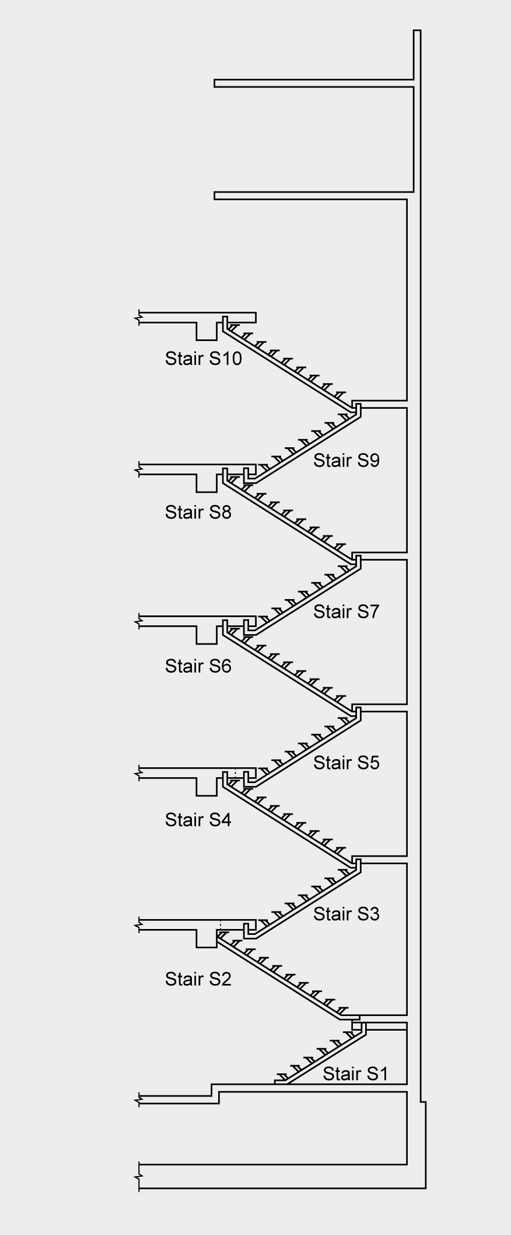

Mr Simson said he formed the opinion that an engineer should be engaged due to the gap that he saw in the stairs, the fact they were unable to access all of the floors, the size and complexity of the building and the method of construction. He said their overall assessment was that an engineer should inspect the building. During cross-examination by counsel assisting, Mr Simson said they did not carry out a Level 2 Rapid Assessment for two reasons: the absence of an engineer in their team and the lack of access to every part of the building. He accepted that regardless of whether they had an engineer with them they would not have been able to complete the Level 2 Rapid Assessment because of this limited access. Mr Calvert said that, because there could be cracks in the foundations or other hidden damage, they were instructed by the CCC to tell owners and occupiers to engage their own independent engineer to obtain a thorough assessment.

Mr Simson said he spoke to both the CTV receptionist and the man they believed to be the building manager. Mr Simson said he explained the need to get an engineer’s assessment urgently due to the size and complexity of the building. Mr Simson recalled telling him it might be best if everyone left the building until it was deemed safe. He said the man told him that he would get it checked immediately.

The three officers decided to issue a green placard because they did not see any obvious damage and they were confident that the person they spoke to had
understood the importance of obtaining an independent engineering inspection. Mr Calvert completed the
Level 2 Rapid Assessment form (see Figure 40). He noted the building already had a green sticker and circled “inspected Green G2” on the form which meant “occupiable repairs required”. Mr Calvert believed he may have taken this to mean the appropriate category was green, second inspection and was therefore circled in error. This indicates a lack of understanding of the
rapid assessment process and what the forms required.

Figure 39: Cross-section of the stairwell in the north wall complex

The CCC officers decided to recommend to the building manager that he engage an engineer to undertake an independent assessment. Mr Flewellen said that recommendation was made because the building was outside their scope and because they did not have an engineer with them.

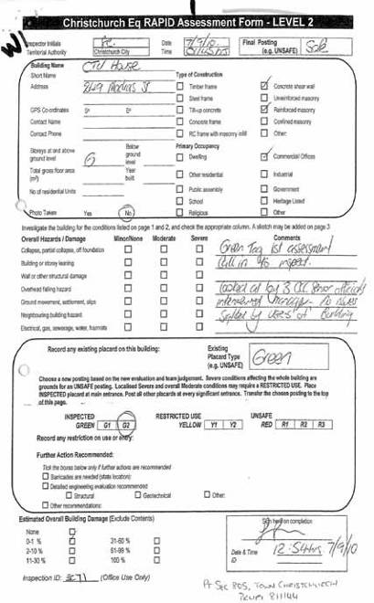Figure 40: The first page of the Level 2 Rapid Assessment form completed by Mr Calvert on 7 September 2010

We note that Mr Calvert did not indicate on the form that the inspection was conducted without an engineer present, nor did he note that there should be a follow- up engineering inspection. He recorded that the assessment was completed by “3 CCC senior officials” but was unable to explain why their seniority was noted.
Mr Flewellen said “we hadn’t seen anything structurally that alerted us…that the building couldn’t withstand… a similar event”. He agreed that the allocation of a green placard meant that any part of the building could be occupied.

3.4.4 Issues with the Level 2 Rapid
Assessment on 7 September 2010

The days following the 4 September 2010 earthquake were difficult for the CCC and its employees. Much of the city was damaged and there were many buildings to assess. Approximately 1236 commercial buildings and 6686 residential buildings were evaluated and most of these evaluations took place in the first week following the earthquake. CCC officers and employees worked hard during this time, even though many must have experienced their own personal difficulties resulting from the earthquake and ongoing aftershocks. However, there were some shortcomings in relation to the assessment of the CTV building on 7 September 2010.

3.4.4.1 Absence of an engineer

A Level 2 Rapid Assessment involves a visual, damage- based assessment of the interior and exterior of the building. The New Zealand Society of Earthquake Engineers’ Guidelines3 provided that an engineer should conduct all Level 2 Rapid Assessments. An overview of these guidelines is given in section 2.3.1 of Volume 7 of the Report. For a high-rise structure with some structural complexity such as the CTV building, an engineer’s assessment was necessary.

Mr Flewellen said he conducted numerous rapid assessments on 4, 5 and 6 September with an engineer and that it was “out of the ordinary” to be directed to conduct the CTV assessment without an engineer. Similarly, Mr Simson agreed that it was a “fixed rule” that a Level 2 Rapid Assessment required an engineer to be in the group. While Mr Calvert’s evidence was that engineers were not always on the assessment teams, he was not aware of any other cases where the assessments carried out without an engineer were Level 2 Rapid Assessments.
Mr McCarthy gave evidence that, as far as he was aware, the Level 2 Rapid Assessment carried out on the CTV building was the only exception to the requirement to have an engineer present. We are not aware of any evidence to the contrary as far as processes followed after the September earthquake are concerned.

However, it is unfortunate that the Level 2 Rapid Assessment of the CTV building on 7 September 2010 was conducted without an engineer. This should not have occurred.

3.4.4.2 Lack of clear instructions

The CCC officers were sent out without a clear understanding of what they were being sent to do. They should have been given clear instructions about what they were to do at the CTV building, including whether it was appropriate for them to consider allocating a placard to the building. The lack of clear instructions resulted in their decision to treat the visit as a Level 2 Rapid Assessment and to confirm the allocation of a green placard, even though an engineer had not assessed the building.

3.4.4.3 Allocation of a green placard

Despite the absence of an engineer, the CCC officers carried out an internal inspection of a limited portion of the building and then confirmed the green placard (see Figure 41). They should not have done so. Instead, they should have made it clear to the occupants that they did not have the expertise or information to conduct a Level 2 Rapid Assessment.

In summary, the inspection carried out on 7 September did not conform to the requirements of a Level 2 Rapid Assessment and should not have been so classified on the assessment forms.

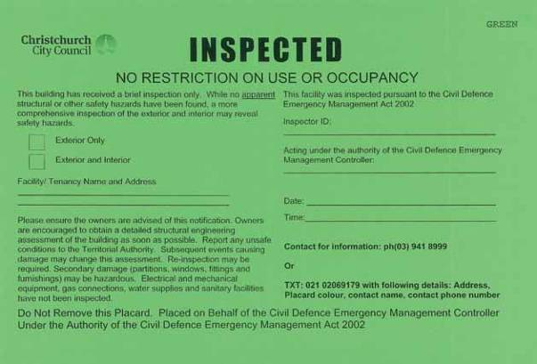

Figure 41: The standard green placard form

We heard evidence that there was a perception among occupants of the building, including the building manager Mr Drew, that the green placard indicated that the building was “safe to occupy”. King’s Education reported in its newsletter that:

Civil Defence engineers inspected the structure and have informed us that it is safe to enter. They have also advised us to get the school underway again as quickly as possible so that things can return to normal.

Within an hour of the inspection on 7 September 2010
Mr Wood, the CTV Manager, wrote in an email to CTV staff, “We have just had an internal inspection of the building from 3 engineers and they have found that this building is in good condition and is deemed habitable”. We discuss the public understanding of the meaning of placards in section 2.4.1 of Volume 7 of the Report.

Although Mr Drew said in evidence that he placed “significant reliance” on the fact the building had been allocated a green placard, he understood that it was recommended building owners obtain their own inspection. However this was not a legal requirement and if a private inspection had not been obtained, occupation of the building could have continued on the basis of the green placard. We discuss the
management of buildings after a state of emergency in section 2.6.2 of Volume 7 of the Report.

Mr Calvert, Mr Flewellen and Mr Simson were all asked when giving evidence why the building was given a green placard when this was inconsistent with their recommendation that the building should be inspected by an engineer. Mr Calvert accepted that the recommendation for an engineering assessment to be carried out should have been entered on the form. Mr Flewellen said their objective was to get an engineer into the building and although a yellow sticker would have ensured the owner had to do this it would have closed the building pending that inspection. They had no reason to believe the building was unsafe for occupancy in the meantime. However Mr Simson said that, in hindsight, “we should have probably at least put a yellow sticker on the building”. A yellow placard would have restricted access to the building until the damage that resulted in the decision to place this placard had been addressed. He said that the distinction between the different placards was still “blurred” at this point. International building safety evaluation literature notes that building assessors sometimes have difficulties understanding when to place a yellow placard.

Mr McCarthy did not know that a Level 2 Rapid Assessment had been carried out. He did not follow up the assessment because they were dealing with “many, many thousands of jobs in the middle of an emergency”. His expectation was that the three officers would come back to him if there was an issue. He said that the primary outcome of their visit was to instruct the building owner to engage an engineer to undertake a proper structural survey of the building. However Mr McCarthy said they should have ensured an engineer inspected the building once they realised a Level 2 Rapid Assessment was required instead of allocating a green placard. He said it was unsatisfactory for a green placard to be placed on a building on the basis that the owner was going to arrange for an engineer to inspect the building in the future.

Counsel assisting submitted that the CCC relying on a building owner to arrange an engineering inspection was “inappropriate and potentially dangerous”. In response, counsel for the CCC emphasised the context. At the time of their visit, only three days had elapsed since the September earthquake, aftershocks were ongoing and there was widespread damage across the city. The CCC was receiving many requests from both commercial and residential building owners for assistance. These requests had to be prioritised and a large number of CCC staff and volunteers had to be managed and allocated to the more urgent response efforts.

When the three officers arrived at the building it was already occupied and a Level 1 Rapid Assessment had been carried out. Counsel for the three officers submitted that at this point it was logical for them to assume they were to carry out a Level 2 Rapid Assessment, and as employees tasked with a specific purpose, they were carrying out their instructions. Counsel for CCC submitted that, although they were aware that a Level 2 Rapid Assessment would normally require an engineer, the officers made the decision to check the building for any obvious signs of damage. Mr Calvert stated in evidence, and we accept that, if the three officers had seen any signs of significant damage at that stage, they would have told the occupants to get out of the building straight away. In addition to this visual inspection, they also discussed with the “building manager” and the receptionist whether they had any specific concerns about any areas of the building. Mr Calvert’s evidence was that they did not indicate any areas of concern.
Counsel for the CCC and counsel for the three officers noted that the officers carried out an assessment of the parts of the building they could access and did not see any signs of significant damage. They checked with two occupants of the building whether they were aware of any issues and they impressed upon everyone they met in the building that an engineer’s assessment was required. Counsel for the officers also noted that there was no evidence that they missed anything of significance in their assessment and referred to the inspection by Mr Coatsworth later that month, which was a more detailed assessment by an engineer, which found no particular cause for concern.

Mr McCarthy also noted that the Level 2 Rapid Assessment was “superseded” by Mr Coatsworth’s subsequent inspection. Although it is correct to say that Mr Coatsworth’s inspection was a more detailed one, the Level 2 Rapid Assessment for this building still raises the concerns addressed above. Some of the building occupants clearly relied on the fact of the green placard and assumed the Level 2 Rapid Assessment to be more authoritative than it was. This can be seen in the email sent by Mr Wood. It was also the basis on which occupancy was resumed in the period before Mr Coatsworth’s report was provided on 6 October 2010.

While the requirement of including an engineer in Level 2 inspection teams was not met and the visual inspections did not examine all of the building’s internal structure, there can be no certainty that if an engineer had been present that the existing green placard would have been replaced by a yellow placard.

3.4.4.4 Training

Mr Calvert said he attended a seminar in 2009 about the Emergency Operations Centre and how this would operate in a state of emergency. This included a presentation by Mr David Brunsdon on the rapid assessment process. It was not something that all building officers were obliged to attend and it was apparent from the evidence of Mr Calvert, Mr Flewellen and Mr Simson that they were essentially relying on the briefings conducted each morning at the Emergency Operations Centre. Mr Simson considered that they “were left to second guess and use [their] combined experience as to what was safe or otherwise”.

This lack of training was further highlighted by the difference in the understanding each had as to the nature of a Level 2 Rapid Assessment. All three officers accepted that more training before the event would have been beneficial.

Mr McCarthy agreed that those carrying out rapid assessments, including the three officers, had had limited training. The system came from the New Zealand Society of Earthquake Engineering and was promoted by the Department of Building and Housing. He said that training to develop a core of expertise about the inspection systems was left to the engineers. However, he accepted that the process needs to be reviewed.

The pre-earthquake training and the post-September 4 briefings with respect to post-earthquake assessments were inadequate. There was insufficient clarity about the requirements for each assessment and the completion of assessment forms.

We address these issues in more detail in section 2.4.5.2 of Volume 7 of the Report.

3.4.4.5 Inadequate information systems

When the three building officers were sent out on
7 September 2010 they, and Mr McCarthy, were unaware that there had already been a Level 1 Rapid Assessment of the building two days earlier. Mr McCarthy said that he would not have sent the men to the building if he had known that it required a Level 2 Rapid Assessment. This illustrates a problem with the records being kept by the CCC at the time.

It is imperative that an adequate information system be implemented quickly and effectively following an earthquake. However we accept the submission of counsel for the CCC that problems with record- keeping resulted from the need to manage a vast amount of information in a timely manner in difficult circumstances. Following the September earthquake Level 1 Rapid Assessments had been carried out for all commercial buildings in the CBD, including the CTV building, by midday on 6 September 2010. These rapid assessment forms contained a significant amount of data which had to be recorded electronically, taking much time and resources.

We discuss the issues with information management during the Canterbury earthquakes in section 2.5.6
of Volume 7 of our Report.

3.5 Engineer’s assessment of the building

3.5.1 Communication between the building manager and engineer

After the inspection carried out by CCC officials on
7 September, the building manager Mr Drew approached Mr Coatsworth to carry out an inspection of the building. Mr Coatsworth is a Chartered Professional Engineer and senior associate with CPG New Zealand Ltd (CPG). He had 40 years’ experience in structural and civil engineering at the time. There had not been any previous contact between Mr Drew and CPG.

Mr Coatsworth sent an email to Mr Drew on
24 September 2010 setting out a proposal for an inspection of the building which included the following:

Thank you for your time given in discussion with myself regarding earthquake damage to your building at 249 Madras Street. I understand that the building owners are interested in having an independent structural assessment carried out.

…

I understand that your building is 5 storeys high and is of reinforced concrete beam and column construction. It has a double lift shaft and services shaft. Floors are suspended concrete which cantilever out at the perimeter of the building supporting concrete spandrel panels.

With regard to damage I understand that you have some cracking of internal linings, some broken windows and a door on the top floor that has jammed.

I suggest that we should allow to carry out a thorough inspection of the building. This would include viewing the exterior from the ground, from windows, from the roof and from whatever other vantage points are available. It would also include inspecting all visible internal surfaces. I would propose that we lift ceiling tiles in appropriate places to inspect under floor surface, beams and beam-column joints where possible. For the purpose of this review I would not suggest removing internal wall linings unless there is some obvious reason to want to do this. For instance, if linings were badly damaged around a column base, then it would be logical to remove the linings to observe the structural elements. We would take photos of any damage and record locations on sketches. Structural and Architectural drawings of the building would be very helpful. If these can be made available, they will help with the understanding of the structural systems within the building.

We would then consider the information obtained form [sic] the inspection and determine if there are any patterns to the damaged [sic] observed that would explain any deficiencies in the performance of the building.

We would then prepare a report describing the building, the damage observed, comment on reasons for the observed damage and briefly comment on possible remedial works. Within the scope of this report we would not anticipate detailing or specifying repair works. Similarly we have made no allowance in our estimate for any analysis of the structure although in the event of significant structural damage it would ultimately be necessary to carry out structural analysis to determine strengthening and repair work requirements.

The assessment Mr Coatsworth proposed has been described in other hearings as a ‘damage-based’ or ‘visual’ assessment. The email noted that it would only be necessary to carry out a structural analysis if significant structural damage was found. Mr Coatsworth said in evidence that he advised Mr Drew verbally that he did not recommend a structural analysis unless damage was observed. The last paragraph of the email quoted above is consistent with that. Mr Coatsworth’s engagement was confirmed in a telephone conversation on 24 September 2010.

3.5.2 Engineer’s inspection and damage report Mr Coatsworth’s inspection of the building took place on September 2010 in the company of Mr Drew and Mr Leonard Pagan, a quantity surveyor from Rawlinsons Limited who was to detail repairs that would be necessary as a result of the damage observed by Mr Coatsworth. Mr Brown of CTV accompanied them on the inspection of the first two levels.

Mr Coatsworth explained that his visual-based inspection took around four hours to complete. During this time he made notes and sketches of damage and took 109 photographs. He spoke to occupants of the building who pointed out damage and described their observations of the building since the September earthquake. Mr Coatsworth decided independently where he should look and what he should examine.

Mr Coatsworth explained that the most obvious form
of damage he was looking for was cracking, particularly in the structural concrete, but also in other surfaces. He was looking for evidence of alignment divergences, settlement and separation between structural elements. Although he did not perform a vertical alignment survey, he made visual observations of vertical alignment.

Mr Coatsworth said that he was able to understand the structural layout of the building. He correctly identified the north wall complex and south shear wall as the lateral load resisting elements, with reinforced concrete beams and columns resisting gravity loads and composite concrete topping and steel tray-deck floors between the shear walls. He said that he understood that the connection between the floor slabs and the north wall complex was essential to the stability of the building and for that reason he expressly looked for cracking in the shear walls and signs of separation between the floors and walls. He did not see any damage which indicated such separation.

Mr Coatsworth observed cracking along construction joints in the walls and stairwells of the north wall complex at several floor levels. He said that these cracks generally measured less than 0.2mm in width with a few up to 0.35mm (see Figure 43). While this constituted minor structural damage, in his view it was not of an order that would signify yielding of the shear walls.
To asses the response of the columns and beams to the earthquake Mr Coatsworth looked for shear and/or flexural bending or cracking in the concrete at beam- column joints or in the columns and beams themselves. He said that the size of any cracking would indicate elastic or inelastic movement. He also looked for signs of compression failure in the columns as a result of vertical loading. He said he looked at every column on each floor. Although he observed some cracking to columns, he was of the view that none of it indicated structural damage. On level 6, the first column west of the north-east corner of the building exhibited some cracking, the appearance of which was accentuated because the paint had chipped off at the cracks. This column was referred to in the hearing as column C18 (see Figure 42). Mr Coatsworth’s recollection was that the cracks were less than 0.2mm in width (see Figure 44).

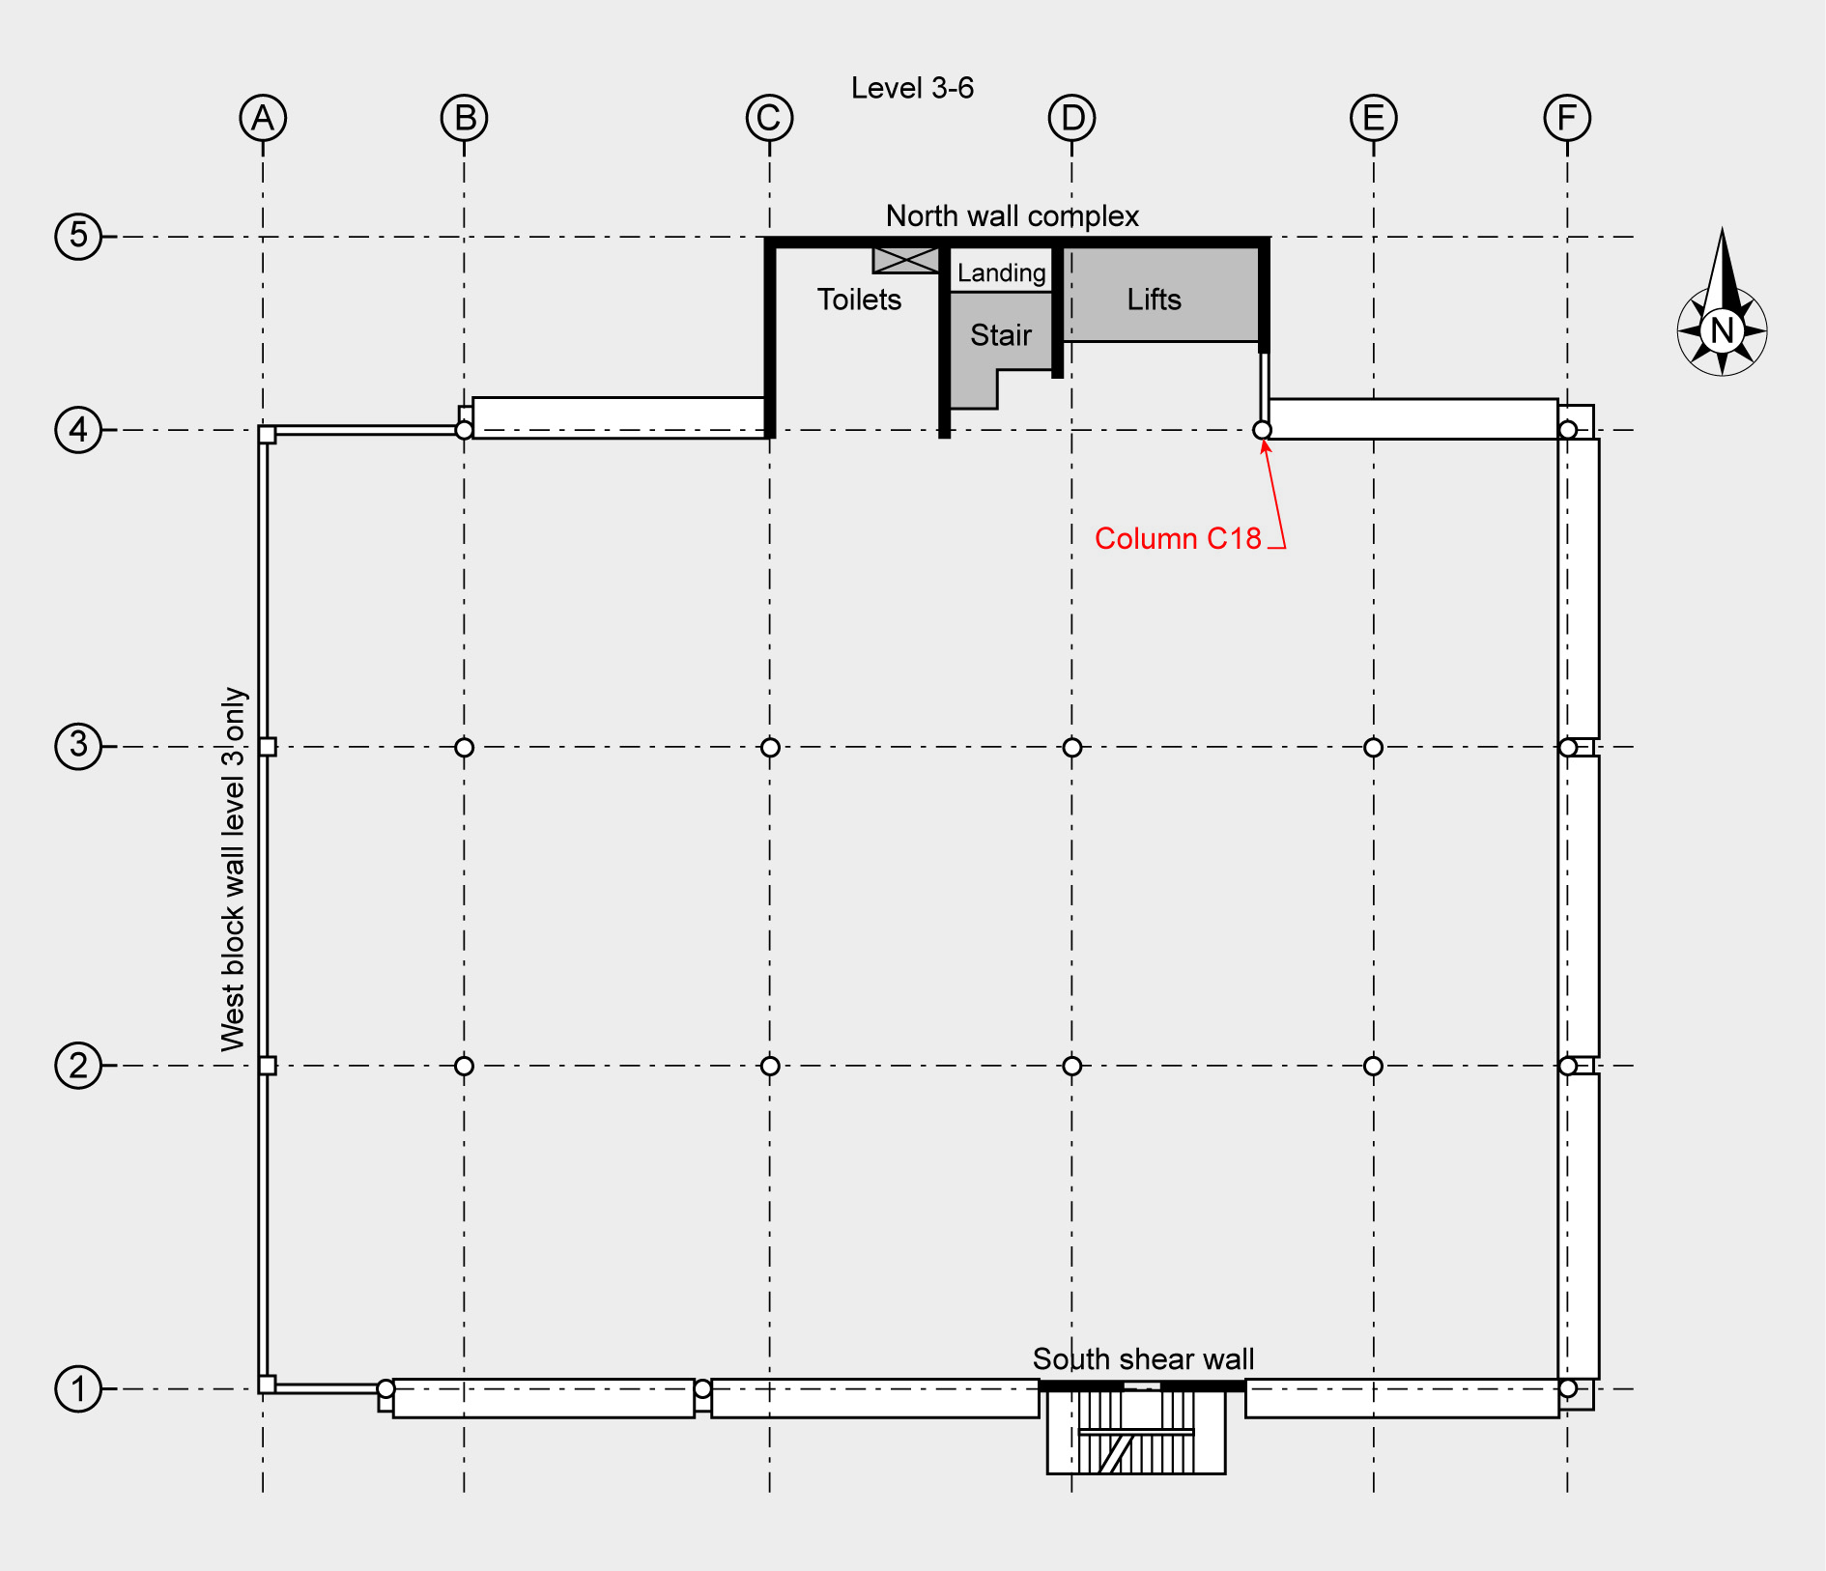

Figure 42: Location of column C18 on level 6

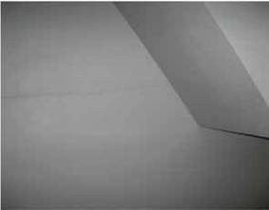

Figure 43: Cracking along construction connections in the north wall complex (source: David Coatsworth)

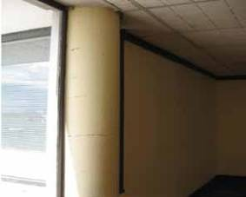

Figure 44: Cracking in column C18 adjacent to lift lobby
(source: David Coatsworth)

Mr Coatsworth said he inspected in the order of 70
(of the 120) beam-column joints in the building, namely all of the exterior columns on lines 1, 4, A and F on Figure 42 and the interior beam-column joints under level 2, which were not concealed by a suspended ceiling (such as that shown in Figure 45). He removed ceiling tiles at one other level above level 2 and examined an internal beam-column joint. He did not see any signs of distress in any of these connections. Mr Coatsworth observed some fine diagonal cracking in some beams but nothing that indicated that the steel had yielded.

Mr Brian Kehoe, a Californian structural engineer, was called by Mr Weston QC, counsel for Mr Coatsworth, to give expert evidence on building assessments following an earthquake. He was well qualified to do so. He is Associate Principal of Wiss, Janney, Elstner Associates Inc, a US firm of structural engineers, architects and materials scientists which undertakes earthquake damage and seismic risk assessments around the

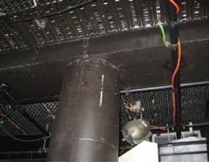Figure 45: Internal beam-column connection under
Level 2 with no evidence of damage (source: David Coatsworth)

world. He prepared his evidence in conjuction with
Mr Terrence F Paret, a Senior Principal, and Mr Conrad
Paulson, a Principal from the firm’s Chicago office.

In cross-examination it was suggested to Mr Coatsworth that he should have looked at more beam-column joints in the upper floors. Mr Kehoe accepted that Mr Coatsworth could have done this, although he did not think this necessarily would have altered the conclusions reached by Mr Coatsworth. We accept Mr Kehoe’s evidence and note that the beam-column joints on level 1 bore the greatest axial load and so were most likely to be affected by the September earthquake. Mr Coatsworth inspected these and found no damage.

Professor John Mander was called to give evidence
by Dr Reay and ARCL. Professor Mander is the Zachry Professor of Design and Construction Integration in the Department of Civil Engineering at Texas A & M University. He expressed the view that the “wings” at the end of the beams (where they met the columns) and the shrinkage of internal column concrete may have concealed any damage. Although we accept that is a possibility, we consider that if there had been any significant damage to the beam-column joints at the time of Mr Coatsworth’s inspection, it is likely to have been evident on the exposed portions of the joints.

Mr Coatsworth examined the south shear wall from level 1 and then from the external fire escape at every other level. The inside face of the south shear wall was finished with a thin coating of gypsum plaster at all levels except level 1, where it was lined with plaster board over a timber frame. The exterior of the shear wall was finished in a plaster splash coat which made fine cracking less obvious than on the gypsum plaster interior walls. However Mr Coatsworth considered that,

in spite of this coat, cracks in the concrete wall which might have indicated yielding would have been visible. He did not see any. He did observe very fine diagonal hair-line cracking in the gypsum plaster on the inside of the south wall at level 2.

At level 1 Mr Coatsworth saw significant cracks in the plasterboard lining and also a fine diagonal crack on the outside of the shear wall. As this crack was fine he did not consider it indicated structural yielding. Given that this was the only crack he observed on the outside of the wall, he considered it unlikely that the south shear wall behind the linings had been compromised. However he did remove a ceiling tile from level 1 in order to inspect a portion of the inside of the shear wall itself. This enabled him to view the level 2 floor/shear wall connections in that location. He reported that these areas revealed no signs of distress. Mr Coatsworth recommended the level 2 plaster board linings be removed to provide further confirmation of whether there had been any damage to the shear wall.

Counsel for Dr Reay and ARCL submitted that the floor slabs may have separated from the south shear wall in the September earthquake and referred to a photograph taken by Mr Pagan. We do not think such separation was likely in September 2010. The photograph of horizontal cracking in the south wall is not indicative of a separation between the wall and the floor slab but rather cracking in the shear wall itself. This is likely to have been the result of torsion resisted by the diagonal reinforcement inducing bond cracks and out of plane actions due to the eccentricity of the perimeter beams with respect to the south shear wall.

Mr Coatsworth noted that the floor construction of
the building consisted of composite concrete topping in a steel tray-deck system spanning north to south between concrete beams. He described these types of floor systems as “relatively light and flexible” and said that it was common for them to “exhibit some deflection”. In fact he found that most floors in the building had high points over the supporting beams and sags in between. In Mr Coatsworth’s view this was not earthquake damage but was common in this type of construction. He had spoken to some of the staff at King’s Education about the deflections in the floor. However Mr Coatsworth was of the view that if the floor had yielded this would have resulted in more significant observable deflections. In addition, he did not observe any damage above the ceiling linings in the area where he removed the ceiling tile at level 1, adjacent to the south wall. He also removed a ceiling tile from the
level 1 ceiling in the CTV storeroom adjacent to the stairwell to view the underside of the floor at level 2 and observed no structural damage.

From his inspection of the non-load bearing concrete block wall on the western side of the building, Mr Coatsworth was able to confirm that the block wall was separated from the columns by a flexible sealant and did not appear to have sustained any damage (see Figure 46). He considered that if the block panels had impacted the columns to any extent there would be damage to the top corners of the block panels. He did not see any evidence of this. He did observe some separation between the block panel and the north-west corner column on level 2. There was a gap between the internal framing/lining and the column at this point through which it was possible to see daylight. From this it was evident to Mr Coatsworth that the flexible sealant between the block wall and the concrete column had fallen out. Although he saw no evidence of any impact between the block panel and the column, he recommended further investigation which would have entailed removing internal linings.

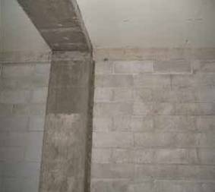

Figure 46: Western concrete block wall
(source: David Coatsworth)

On 6 October 2010 Mr Coatsworth returned to the CTV building to complete elevation sketches of the inside of the north wall complex because he had not completed a full sketch during his initial inspection. He also rechecked the width of the cracking in these walls.

Mr Coatsworth explained that it was his normal practice to discuss any preliminary conclusions from an inspection with colleagues or other specialists in relevant fields. He said this form of peer review was useful in checking his own opinions. It was a matter of risk mitigation common across most engineering practices. Mr Coatsworth spoke to Mr Dene Cook of Firth Concrete, an expert in concrete performance, and Professor Desmond Bull of the University of Canterbury, who was also a practising structural engineer with considerable expertise in reinforced concrete structures. Mr Coatsworth also made inquiries with two epoxy injection repairers and discussed his findings with two of his structural engineering colleagues at CPG. In cross-examination it was suggested to Mr Coatsworth that his inquiries of these people may have been an indication that he was uncertain about his conclusions. He did not accept this. He said he regarded it as a form of peer review. We accept Mr Coatsworth’s evidence.

Mr Coatsworth’s findings and conclusions were provided in an earthquake damage report dated 6 October 2010 that was emailed to Mr Drew on 8 October 2010. In Mr Coatsworth’s view, although the building showed noticeable damage to non-structural elements such as linings and finishings, and some minor structural damage, there was no evidence of structural failure.

On 19 October 2010, there was a relatively shallow aftershock of magnitude 5.0. Mr Coatsworth said Mr Drew telephoned and asked him to “take another look at the building” that afternoon, which he did. Starting at level 1, he had a general look around the building including walking up the stairs in the north wall complex. He spoke to the receptionist on level 6. Apart from two cracks being possibly slightly larger, he saw no additional damage to the building. Mr Coatsworth took an additional nine photographs. The cracks he had previously observed in the column on level 6 did not appear to have increased. He emailed Mr Drew that afternoon confirming his findings and his view that the building remained structurally sound. (In evidence, Mr Coatsworth explained that by this he meant the capacity of the building to resist gravity and lateral loads had not been significantly reduced.) However he told Mr Drew that it was “inevitable that where cracks had been caused by the initial earthquake, subsequent aftershocks could work the connections and open them further”. He therefore recommended that arrangements to repair the walls by epoxy injection be made as soon as practicable.
That ended Mr Coatsworth’s involvement with the building. He said he had no further contact with Mr Drew and was not requested to conduct any further assessments.

Mr Coatsworth and all of the engineers that gave evidence carried out damage-based assessments. The underlying approach was that, if the building did not appear to have suffered any significant structural damage following the September earthquake (which was considered to be at about the “design” intensity to which new buildings would be designed), then it should be able to survive another earthquake of similar, or lesser, intensity. This approach also appears to be international best practice as stated in evidence by Mr Kehoe. We do not consider that Mr Coatsworth can be criticised for his inspections of the building. Although he was not aware of it at the time, the columns and beam-column joints were not detailed for ductility. With ductile detailing damage is evident well before collapse occurs. Without ductile detailing collapse can occur with little warning. Although this lack of ductile detailing could have been identified from the structural drawings, it would have required close scrutiny to do so.

Mr Coatsworth said that he did not receive any information from GNS Science or any other source about the likelihood, location and extent of further aftershocks. He, like others, did not expect an aftershock producing greater horizontal ground accelerations than the September earthquake had generated in central Christchurch. While GNS Science could not have predicted the ground accelerations of the February earthquake, it is vital that in future as much information as possible is provided to engineers carrying out post-earthquake inspections. We discuss this and make recommendations about how and when to account for aftershocks in section 2.4.3.4 of Volume 7 of the Report.

As we have said, the damage-based inspection carried out by Mr Coatsworth was consistent with the approach of most, if not all, engineers in the aftermath of the September earthquake. It was not common, or considered necessary, for engineers to analyse the structural drawings of a building when carrying out this type of assessment if the observed damage did not indicate a need to do so. We deal with the issue of structural drawings in the following section. However we are of the view that, in terms of the damage-based inspections that were being conducted after the September earthquake, the inspection carried out by Mr Coatsworth was thorough and competent. Indeed, of all the inspections we considered in evidence over the course of the Inquiry, Mr Coatsworth’s was the most thorough.

3.5.3 Communication between engineers and laypeople

Mr Drew said in evidence he wanted an engineer’s inspection to determine whether the building was safe to occupy and what repairs were necessary. When it was put to him that the email of 24 September 2010 did not refer to the phrase “safe to occupy”, Mr Drew said that he could not specifically recall saying that to Mr Coatsworth but believed it had formed part of their conversation.

Mr Coatsworth said that to the best of his recollection he was not asked if the building was “safe to occupy”. He said that, as an engineer, he does not use the term “safe” because it is too broad and imprecise. However he did understand that a layperson might construe a finding that a building had not been damaged as meaning that it was safe. While it was not his intention to imply this, he accepted that he stated in his report that there were no obvious structural failures and in an email on 19 October 2010 that the building was still “structurally sound”. Further, on neither occasion did he recommend that the building be vacated. He saw no reason to do so given the limited damage observed and his conclusion that the capacity of the building to resist gravity and lateral loads had not been significantly reduced. Mr Coatsworth properly accepted that by conveying these conclusions he was in effect stating that the building was safe to occupy.

It is clear that what engineers mean by the word
“safe” and what the general public understands
by it are different. This hearing and earlier hearings have highlighted the need for clarity in the language engineers use. Clarity is also required in the communication of the type and extent of a proposed engineering assessment. There is a continuum of inspection methodologies ranging from visual, damage- based assessments to a quantitative structural analysis. An engineer must sufficiently communicate what an assessment will involve so that the client (and later users of the building) will be adequately informed of the nature and extent of the assessment.

An issue was raised in this case as to whether
Mr Coatsworth adequately communicated the inherent limitations involved in a damage-based assessment to Mr Drew. As a layperson, Mr Drew was entitled to rely on Mr Coatsworth to advise him about the appropriate assessment. In advising Mr Drew that only a damage- based assessment was needed, at least initially, it would have been preferable for Mr Coatsworth to have clearly explained what it would and would not include and the subsequent implications.
Mr Coatsworth accepted that the assessment he carried out was essentially governed by what he proposed rather than what he was asked to do. Given a layperson will usually rely on the advice of an engineer, this is likely to be a common situation; hence the need to explain the nature and extent of an assessment in clear terms. Mr Kehoe agreed that there should be clear communication about the type of assessment an engineer has carried out so that the owner and tenants understand what has been done.

These observations are directed more to lessons that can be learned rather than criticisms of Mr Coatsworth. We consider that the way he communicated and the type of assessment he recommended and then carried out was common to most engineering assessments in the post-September earthquake period.

3.5.4 Structural drawings

Before his inspection of the building Mr Coatsworth asked Mr Drew whether any structural or architectural drawings of the building were available. Mr Coatsworth considered these would be useful to familiarise himself with the structural systems of the building. Mr Drew did not have the drawings so he put in a request to the CCC for the building file. He was told that it might be some eight weeks before the file was available. Mr Coatsworth telephoned the CCC and was told that the files were not available because of the disarray in the filing system following the September earthquake. He believed he could conduct a meaningful assessment of the building without the drawings and proceeded with the inspection. He considered that he was able to identify the key structural systems from a visual inspection.

Mr Coatsworth said that he did not make any further attempts to obtain the drawings after his inspection and subsequent report as he had not observed any significant structural damage. He said that, had he found any significant damage he would have obtained the drawings or recommended that the client do so, since information from the drawings would be necessary to perform a quantitative analysis of how the structure had responded to loads experienced in the September earthquake.

The CCC notified Mr Drew that the building file was available after he received Mr Coatsworth’s report on 8 October. He went to the CCC office and noted that the structural drawings were on the file. Mr Drew
said that, because Mr Coatsworth’s report had been completed, he thought that perhaps Mr Coatsworth did not need the drawings after all or that he had obtained

them independently to produce the report. However, Mr Coatsworth’s report stated that he had not sighted any structural drawings as they were unavailable.

As building manager, Mr Drew can be criticised for not contacting Mr Coatsworth about the drawings once they were available, particularly given that he knew that Mr Coatsworth had wanted to see them but had not. However such criticism has to be qualified by the fact that Mr Coatsworth did not ask Mr Drew to notify him if the drawings became available. In any event, as Mr Coatsworth explained, he did not consider that the drawings were a prerequisite to the damage-based assessment he carried out.

Counsel for Dr Reay and ARCL submitted that Mr Coatsworth’s failure to review the structural drawings was a critical omission. Applying the standards and procedures that were adopted by most if not all engineers at that time, we do not consider this criticism is justified. However lessons can be learned for future inspections following a significant earthquake. Mr Coatsworth accepted that the inadequate connections between the north wall complex and the floor slabs would likely have been identified had he reviewed the drawings. This may have prompted him to reconsider the type of inspection he was carrying out or to conduct a more invasive damage-based inspection.

The difficulty with a solely damage-based inspection of such a building was highlighted by the evidence of Professor Priestley. He said that, if the reinforcing mesh in the floor slab had fractured in the September earthquake, it was possible that such a crack may have only been 2mm in width and not observable on a visual inspection without removing floor linings. Mr Kehoe accepted that a crack of 2mm may not have shown up through the vinyl floor coverings.

Mr Kehoe gave evidence in support of Mr Coatsworth’s inspection methodology and conclusions. He said that such an inspection did not necessarily require access to structural drawings, although he agreed that if they had been available for the building they would have shown Mr Coatsworth that his assumption that the beam- column joints were constructed in the standard fashion with steel reinforcing through the connection was incorrect. They would also have shown him that there were issues with the connection between the north wall complex and the floor slabs. Although he expressed the view that the drawings might not have changed Mr Coatsworth’s opinion, Mr Kehoe agreed that it would be a good idea to require perusal of structural drawings in post-earthquake inspections.
As we have noted, the majority of engineers in
Mr Coatsworth’s position at that time would have proceeded in the same way that he did. However we consider that in future, it is advisable that all inspections of multi-level buildings that are owner-initiated and outside the emergency response period should include a review of the structural drawings if they can be obtained. However, we note that authorities may not have drawings of all buildings. In section 2.5.6 of Volume 7, we discuss the advantages and disadvantages of storing structural drawings and building records electronically.

A possible alternative to the need for inspecting engineers to access structural drawings would be to implement San Francisco’s Building Occupancy Resumption Program (BORP). Building owners registered with this programme contract their own engineers to assess their building after an earthquake against previously collated baseline information. We consider the advantages and disadvantages of this in section 2.4.6 of Volume 7 of the Report.

3.5.5 Vertical cracks in the lift shaft

Mr Graeme Smith, a qualified engineer and concrete repairer, visited the building in early February to provide a quotation for repair of the cracks identified in Mr Coatsworth’s report. We refer to his observations in section 3.6.7.1. Mr Smith inspected the inside of the lift shaft and observed horizontal cracks which corresponded to the cracking that Mr Coatsworth had observed in the stairwell. Mr Smith also saw two vertical cracks that ran down the length of the inside of the north wall of the lift shaft. Although they were not referred to in the Coatsworth report, Mr Smith said these cracks did not concern him.

Mr Coatsworth had not examined the inside of the lift shaft on his inspections. In evidence he said he thought the vertical cracks might have been construction joints or blemishes in the form-work. However, we consider that Mr Smith’s evidence on these cracks was clear. Further, we think that this type of cracking would be expected if there was twisting of the north wall complex, as would be expected in the September or Boxing Day earthquakes.

Counsel assisting submitted that it was unfortunate that Mr Coatsworth did not inspect the lift shaft. We do not consider that there is any basis on which to criticize Mr Coatsworth for this. Mr Smith obtained access to the lift shaft because he was trying to determine whether the cracking observed in the stairwell could be repaired from inside the lift shaft.

It was unnecessary for Mr Coatsworth to access the lift shaft to properly inspect the north wall complex and its connections to the floor slabs.

3.5.6 Recommendations not carried out

Mr Coatsworth made two recommendations for further investigation in his report of 6 October 2010. These were the removal of the interior strapping and plaster board lining in the master control room adjacent to the south shear wall on level 1 and a check of the western block wall. The first was the more important.

Mr Drew said that the plaster board lining was not removed because he was having discussions with CTV at that time about vacating the tenancy. Removal of the plaster board lining in the master control room would have required shifting equipment essential to the operation of the studio. Having spoken to Mr Coatsworth, Mr Drew’s impression was that removal of the lining was not urgent.

It would have been preferable for Mr Drew to have ensured that this recommendation was carried out expeditiously. However, Mr Coatsworth said that he did not expect the damage to be significant and assumed that his recommendation would be carried out “in time”. He said that if he had suspected that there was serious damage he would have removed the lining himself at the time of his inspection.

Mr Coatsworth said in evidence that around 1 October
2010, following his initial inspection, he telephoned
Mr Drew and advised him that a security fence should be erected around the bottom of the fire escape on the south face of the building to prevent injury to people walking beneath those stairs should plaster fall from the beam-ends. Mr Drew said that he could not recall receiving such advice from Mr Coatsworth and it was not done. We accept that Mr Coatsworth made this recommendation to Mr Drew. Mr Drew should have addressed it. Although a compromised fire escape may have led to the CCC closing the building, even if this had occurred any closure would almost certainly have been of short duration. It is very unlikely that it would have resulted in the building being unoccupied on 22 February 2011.
3.5.7 Cumulative damage and low cycle fatigue In cross-examination by counsel for Dr Reay and ARCL, Mr Coatsworth was asked whether he considered the effects of low cycle fatigue or cumulative damage when carrying out his inspections. Mr Coatsworth explained that he did not carry out any calculations to determine the building’s capacity. Rather, he had proceeded on the basis that, because he did not believe the building had been significantly damaged, it could withstand another earthquake of the same or similar magnitude to the September earthquake. He said he was able to draw that conclusion without carrying out any calculations because the limited amount of damage he observed indicated to him that the structure had not yielded and therefore its capacity had not been significantly diminished.

In cross-examination Mr Coatsworth also said that he had considered that there may have been damage within the building not observed by him and not capable of being observed without significant investigative tools. Professor Priestley said that crack widths in columns can be misleading when considering the behaviour of the columns. He said:

During the earthquakes the crack widths may have been very much larger but due to the high vertical loads on the columns these cracks could almost completely close up when the shaking associated with the earthquake ceased.

He thought this was a difficulty in the assessment of reinforced concrete buildings that may not have been fully appreciated in the past.

Dr Bradley, who was called as a witness by Dr Reay and ARCL, referred to the difficulty with a damage- based assessment:

…the lack of observable damage in post earthquake inspections does not imply that damage did not actually occur. For example, Professor Priestley… notes on paragraph 80 of his evidence that crack widths of only 2mm would be required to fracture the mesh in order to commence the disconnection of the floor diaphragms to the North Core and this may not have been easily identified. Analyses for Compusoft Engineering Ltd, both in the initial report and revision as part of the NLTHA panel indicate that such disconnection is likely to have occurred (specifically they found disconnection in the case in which the input ground motion was from the CCCC station, but no disconnection in the case of using CBGS ground motion).

Dr Bradley’s reference to the NLTHA panel relates to
the panel of experts whom we directed to confer about non-linear time history analysis. This is described in more detail in sections 5, 6 and 7 of this Volume.

Professor Mander said, “it can be argued that with the level of observed as well as hidden damage, CTV building should have been red-stickered” following the September earthquake. He went on to contend that, even without inspection by the CCC, because the September earthquake was a “design level” earthquake, the building should have been red- stickered “by fiat” without the need for any inspection.

Mr Kehoe did not agree with this argument. He considered that buildings normally have more strength than what they were designed for, so the fact that they may have experienced a design level event does not necessarily mean that the event had caused the level of damage that might be expected when the building reached its capacity.

In relation to the contention that the building should have been red stickered without inspection, Mr Kehoe said this was not something that applied in the United States and he had never heard of it being promoted or applied. He made the point that, in order for it to be applied, inspectors carrying out a Level 1 Rapid Assessment would need to know what the design level earthquake was for every building they inspected. He did not see this as a practical solution.

Professor Mander also raised the issue of eyewitnesses reporting on what came to be referred to as the building’s “liveliness”. In his view this should have served as a signal and confirmation to inspecting engineers that the building had sustained some hidden damage.

Mr Coatsworth acknowledged that he spoke to a number of occupants of the building when he inspected it on 29 September 2010 and took their observations into account. He did not go back to the building after 19 October 2010. However he did comment on the issue of “liveliness”, saying “I think those sort of comments are very hard to assess, people’s impression of movement after an earthquake I think became much more heightened”.

The whole basis of the assessment conducted by Mr Coatsworth was that any significant structural damage that was “hidden” would still be apparent from visible damage to the structure or linings. This is the test that was generally applied following the September earthquake and, as was apparent from
Mr Kehoe’s evidence, the test that is applied in the United States. Although we cannot be certain that there was no “hidden” damage, there were no indications of this to Mr Coatsworth. Given the thoroughness with which he conducted his visual examination, we consider it unlikely that any significant damage was present.

However these comments highlight the difficulties with a solely damage-based assessment following a significant earthquake. In our view, while a damage- based assessment is a necessary component of the rapid assessment process, it cannot be the sole basis of assessment of whether a building like this should be occupied in the long term. We discuss the appropriateness of using damage-based assessments in section 2.4.3 of Volume 7 of our Report.

3.6 Boxing Day earthquake

3.6.1 Introduction

On Boxing Day 2010 a sequence of aftershocks, which are described in Volume 1 of this Report, struck directly under the Christchurch CBD. Although the magnitudes of these aftershocks were relatively small, the epicentre was within the CBD and mostly occurred at depths of 3.7–7.0km. The sequence began with a moment magnitude (MW) 4.7 earthquake at 10:30am, followed by magnitude (ML) 4.6 and 4.7 events later that day. The initial earthquake was the most damaging and is referred to as the Boxing Day earthquake. The epicentre was located 1.8km north-west of the Christchurch Cathedral at a depth of about 4km.

A civil defence emergency was not declared. From
27 December, the CCC sent teams out to commercial parts of the CBD to undertake Level 1 Rapid Assessments. In addition, USAR carried out rapid visual surveys of buildings.
3.6.2 Level 1 Rapid Assessment following the
Boxing Day earthquake

A Level 1 Rapid Assessment of the CTV building was conducted on 27 December. The inspection team included Ms Marie Holland, a CCC building inspector with a Bachelor of Architectural Design degree. The other members of her team that day are not known, however Ms Holland speculated she may have been joined by Mr Glenn Mackel, also a CCC building inspector. Ms Holland completed the Level 1 Rapid Assessment form and allocated a green “Inspected” sticker. The form made no recommendation for
further action.

Ms Holland was present at the briefings delivered by Mr John Buchan of the CCC following the September earthquake. Those present were instructed to carry out Level 1 Rapid Assessments to identify any obvious building damage and/or external hazards which could pose a danger or risk of injury to members of the public. She did not receive any training in the rapid assessment process before this. However she understood the distinction between the Level 1 and 2 Rapid Assessments. Ms Holland was told to use the same criteria used during the post-September Level 1 Rapid Assessment process for assessments of buildings after Boxing Day.

Ms Holland was unable to recall the assessment of the CTV building but did remember conducting assessments in the general vicinity. She was shown a copy of the Level 1 Rapid Assessment form for the CTV building and was able to confirm that the handwriting on the form was hers except for the words “CTV” and “219 Madras Street” (as well as the CSR filing number). It is not known who wrote the words “CTV” and “219 Madras Street” on the form. (We note that normally the CTV building’s address is given as 249 Madras Street in CCC records). The only comment written on this assessment form refers to an overhead falling hazard from “glazing” and states, “glazing if dislodged will fall into self-contained balcony”.

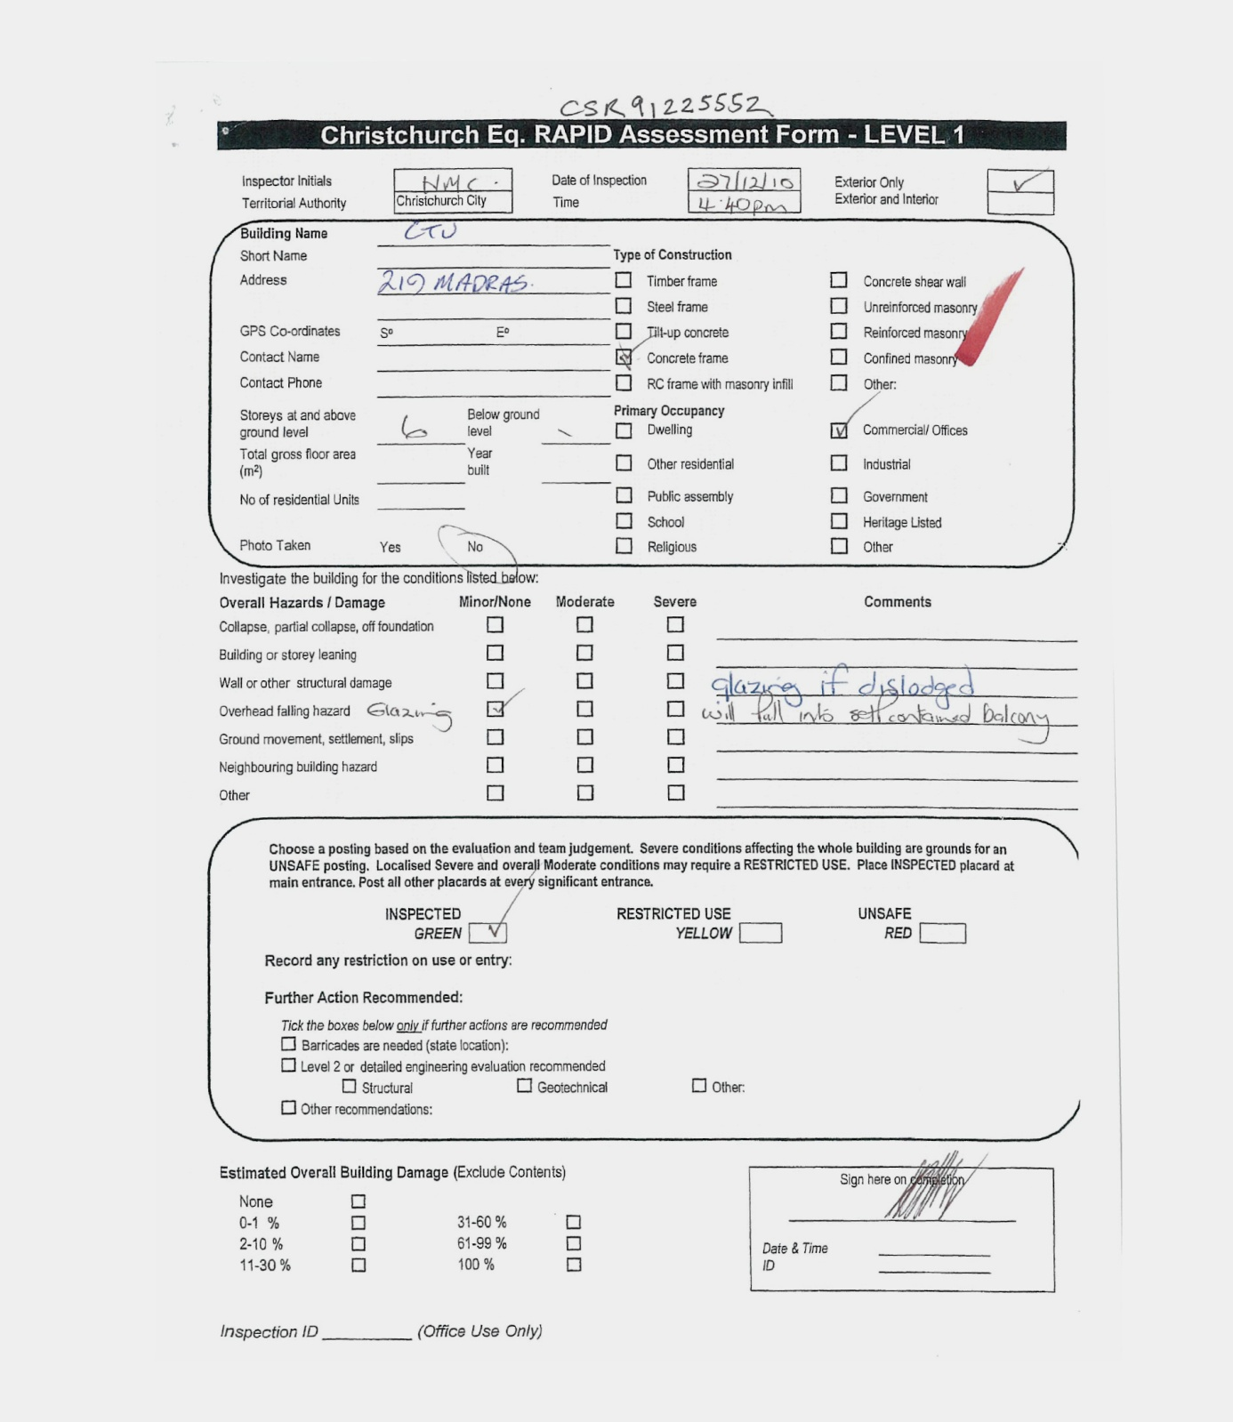

Figure 47: The Level 1 Rapid Assessment form signed by Ms Marie Holland

3.6.3 USAR rapid visual survey following the
Boxing Day aftershock

In addition to the CCC external inspection, USAR was asked to assist with rapid visual surveys of buildings following the Boxing Day aftershock. Mr Andrew Ayers, a member of the New Zealand Fire Service and USAR gave a statement to the Royal Commission dated 21 May 2012 to explain his involvement.

Mr Ayers did not recall who had requested the assistance of USAR. On 27 December 2011 he carried out the rapid visual assessment along with a colleague. He said in his statement:

6. We were tasked to undertake a rapid visual survey from street level of damage to buildings to check for any obvious signs of immediate danger to the public. We were given ‘USAR Damaged Building Reconnaissance Report’ forms to fill out. We were told not to worry about whether damage looked old or new.
7. The criteria we used to assess buildings on
27 December 2010 was very different to the sort of criteria that I imagine a structural engineer might use. We were only concerned with issues of immediate public safety, such as buildings that were at obvious risk of collapse or where materials had, or were, falling off and were posing a risk to people or property. If we saw anything that looked serious, we would phone up the TF2 engineers and request their assistance.

8. In relation to the CTV building, my colleague and I completed a visual survey of the building from each direction. This included the alley between the CTV building and the Arrow International building. I noticed that there was glass on the ground which had come from the Arrow building. We also went up the alley between the Arrow building and the AA building. The older building next to the new Les Mills had many bricks that had fallen down, as did the back of Occidental Hotel (on Hereford Street). We spent quite some time blocking off public access to the areas around these buildings. It is likely that we noted on those report forms that an engineer’s assessment was required.

9. From all angles the CTV building looked fine to me and did not appear to pose an immediate danger to the public. There was no obvious structural damage, obvious cracking in the columns, and no tell-tale signs on the ground e.g. spalled concrete. The only damage I observed was one broken window and pieces of glass which had fallen out onto cars in the car park below. We applied temporary hazard tape around the area beneath the broken window. I noted my observations on the report form for the CTV building. I estimated that the overall damage visible from the street was 0 – 1 %. Based on what I saw I did not consider that an engineering assessment was required.
The evidence of Mr Ayers was consistent with the green “Inspected” placard that was issued by the CCC. The information provided to the Royal Commission does not show whether the CCC inspection or the USAR inspection took place first on 27 December 2010.

3.6.4 Building Manager

At the time of the Boxing Day earthquake Mr Drew was not in Christchurch and he was out of cellphone range. The shaking that he experienced did not register as a major event until the following day when he was able to clear his cellphone messages. At this stage he returned to Christchurch as the building in which the medical practice he managed was located in Gloucester Street was red stickered.

He gave the following evidence about his attempt to contact Mr Coatsworth at the CPG office:

I rang the CPG office when I got into town. They had closed for holidays. I got a voice message, an automatic message saying they will re-open I, think it was on the 9th of January so, I did nothing more than that, I thought I could do nothing more than that until the New Year… I don’t recall the exact date.

His intention at the time was to arrange for Mr Coatsworth to return and inspect the building in order to confirm his own observations that there was no additional new damage. Mr Drew did not follow up on having an engineer inspect the building and thought “my energies were better employed getting that next phase underway”. That “next phase” was to get the concrete repair engineers on site to repair the damage that had been identified from the earlier report by Mr Coatsworth.

3.6.5 Occupants’ concerns

During the hearing, we heard from a number of people who had been in the building between the Boxing Day and February earthquakes. The following is a summary of the damage to the building that they recalled.

3.6.5.1 Lift Shaft

Mr Stephen Kissell, a contractor who provided access to the liftwell for an inspection on 18 February 2011, gave evidence about the cracks by the lifts. Mr Graeme Smith operates the business Concrete Protection and Repair Limited and carried out inspections and prepared an estimate for repair of the damage from the September earthquake. Mr Smith and Mr Kissell both recalled horizontal and vertical cracking in the lift shaft. The horizontal cracking aligned with the construction joints at each floor. There was also cracking about

halfway up each floor corresponding to the landings for the stairs and the adjacent stairwell. Both types of horizontal cracking were present for the full height of the western lift shaft wall and the northern wall but not the eastern wall.

Mr Smith recalled two vertical cracks on the northern wall. The cracks approximately measured 1m and 1.5m and were in the range of 0.2–0.5mm wide. He noted that there was no spalling at any of the cracks. Mr Kissell was unable to confirm exactly how many cracks he saw or exactly where they were.

3.6.5.2 Level 1

3.6.5.2.1 South wall

Ms Spencer recalled that existing cracks in the south wall of the master control room increased to about 2–2.5m in length, which she said was almost the whole length of the wall. She said although the overall width of the crack did not increase, several smaller cracks appeared leading off it.

3.6.5.2.2 North wall

Mr Godkin said he noticed damage at ground level about 2–3 weeks before the February earthquake. A concrete non-supporting wall at the end of the car park area had collapsed eastwards while another wall had dropped and separated from the roof above it by about 20mm or so. Neither of these walls was load bearing.

3.6.5.3 Level 2

3.6.5.3.1 North-west corner

Mr Hawker said pinhole cracks appeared in the north- west corner. He saw daylight coming through them.

3.6.5.3.2 South wall/East wall

Ms Jackson recalled two windows had broken on the east wall and one on the south wall.

3.6.5.3.3 Internal

Ms Spencer was sure that the cracks in the internal walls in the north-eastern end of the building had increased, although she was unable to say to what extent. She also recalled a significant crack around an internal pillar directly south of the western wall of the north wall complex. The carpet along the edge of the internal wall had separated from the pillar by about 10mm.
3.6.5.4 Level 4

3.6.5.4.1 Internal

Ms Aydon said the crack in the video conference room had increased to the full length of the pillar running ceiling to floor. At the top of the pillar it was approximately 50mm in width.

Ms Aydon considered that whatever was causing the reception desk to slope had increased. They would use Blu-Tack and rubber-bands to stop pencils rolling off the desk. Ms Brehaut gave similar evidence and said that her pen had not rolled when she worked at reception in November.

3.6.5.5 Level 6

3.6.5.5.1 Internal column

Mr Bainbridge recalled a damaged column on the corner of an internal room on the west side of the building. He said the column had cracks in it but he did not examine it closely.

3.6.5.5.2 Exterior spandrels on north wall

Mr Bainbridge recalled a damaged spandrel between levels 5 and 6 towards the north wall of the building. He said the spandrel was not in line with the building by about 100mm and was damaged and chipped at one end. He believed it had experienced significant movement and had been compressed against the north wall complex.

3.6.5.5.3 Stairwell

Ms Cammock noticed cracks had appeared up the stairwell in the north wall complex. She only noticed cracking around levels 5 and 6. She observed fallen bits of plaster and debris. The lights were not working and these were never replaced.

3.6.5.5.4 Window frames

Mr Phillip Reynish, who was contracted to facilitate the re-branding of the building in late January 2011, noticed damage around the perimeters of the windows along the eastern side and part of the south side of the building on level 6. He said that in some places he could see large gaps where the steel window frame had pulled completely away from the concrete window opening.

3.6.5.5.5. North wall complex

Ms Cammock and Ms Kulpe said the cracks running up either side of the lifts increased after the Boxing Day earthquake. Ms Cammock described them as “deep” and said they ran vertically from floor to ceiling. She wasn’t able to say exactly how wide they were but speculated they would have been approximately a quarter to a third of the width of a pencil. However she said they were easily visible, even from a distance of approximately 10m away. She said it looked like someone had pulled the wall slightly apart. Ms Cammock said the two cracks were often discussed in staff meetings. Ms Vivian remembered speaking with her husband about the cracks but could not recall exactly where they were.

Mr Kissell was particularly concerned about the crack on the eastern wall and confirmed it ran from under the windowsill diagonally towards the corner of the lift. He said its width was approximately 3mm.

Several witnesses gave evidence that the cracks to the column outside the lifts (column C18) were more noticeable. Mr David Bainbridge said the damage he saw in February was worse than the damage visible in a photograph taken on 6 October. The photograph showed two cracks while he recalled three cracks of approximately 5mm in thickness, as well as other hairline cracks of about 2–3mm in thickness. The cracks ran all the way around the column at about 200mm intervals. Mr Bainbridge recalled flakes of concrete, some as big as a 50 cent coin, had dislodged at the base of the column exposing the aggregate inside.

Ms Vivian recalled the cracks were in a spiral pattern and confirmed they appeared to go right around the column. They were approximately 10mm in width and 1–1.5m in length. Ms Vivian was worried about the damage to the column so she contacted the CCC on 5 January 2011 to arrange an inspection of the building. The CCC computer record of that call notes that Ms Vivian referred to “a round structural pillar … (which) has significant cracks in it”. Ms Vivian later withdrew that request for an inspection after speaking with Mr Drew. Her evidence about this is referred to in greater detail later in this section.

Mr Peter Higgins took photographs of the damage
as part of a scope of preparing a quotation for repair works for Mr Drew. He photographed the cracked column referred to by Mr Bainbridge and Ms Vivian. It also shows damage to an overhead lintel beam. Mr Higgins’ evidence is referred to in greater detail later in this section.
Mr Bainbridge also recalled water damage on the plaster board at the top of column C18. This was a brownish discolouration on the ceiling panels that went about a metre inwards from the column.

The cracking seen in the photographs taken by Mr Higgins and Mr Pagan (Figure 50(a) and (b)) may indicate that damage had occurred to the connection of the column to the wall D–E at level 7 (see Figures 7 and 8). This may have contributed to increased flexibility in the building because the column contributed to the performance of the north wall complex. Other contributors to the liveliness may have been possible slippage of the drag bars attaching the level 4, 5 and 6 floor slabs to the north wall complex and damage to non-structural partitioning.

Witnesses described the floor of the building as having some movement before the September earthquake from people walking around and from the fitness centres (a fitness centre was previously located on level 5 and Les Mills Fitness Centre had recently moved from the adjacent lot). However, occupants of the building described it as having more movement following the September earthquake and some recalled it having even more movement following Boxing Day. It was described as responding to traffic in the street and, in particular, there was alarm at the way the building responded to the demolition of a building immediately to the west.

Ms Jackson appears to have been so convinced that the building was at risk that she would run from it each time there was a large aftershock. She managed to flee from the building as it collapsed behind her in the February earthquake.

3.6.6 Request for CCC inspection

As can be seen from the summary above, building occupants continued to hold serious concerns after the Boxing Day aftershock. In particular, Ms Vivian, who was a manager with Relationship Services on level 6, said she concluded that the building had not been inspected when she saw no sticker on it on 2 and 3 January. She came in through the main lobby that day, which gave access to the north wall complex and levels 3-6, and did not remember seeing a sticker there. Council records show that a Level 1 Rapid Assessment was carried out on 27 December so it is difficult to reconcile this with Ms Vivian’s evidence that no sticker existed. This may, however, indicate that the sticker was only on the CTV entrance, which was on the south-east corner of the building, rather than the main lobby entrance on the north-east corner.

Ms Vivian contacted the CCC on the morning of
5 January 2011 (the first working day of 2011) to arrange an inspection after becoming concerned about cracks to the column in the level 6 foyer. A copy of the CCC computer record notes that call (see Figure 48).

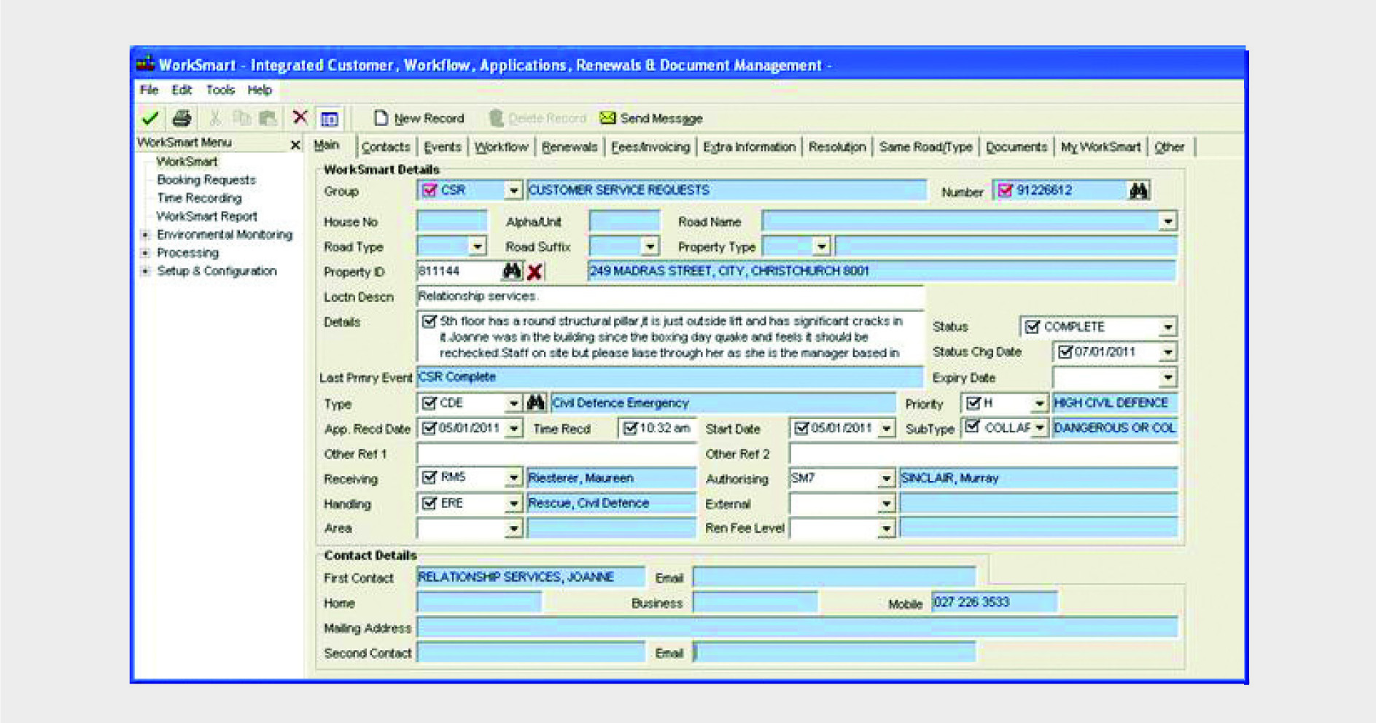

Figure 48: CCC computer record of Ms Vivian’s telephone call on 5 January 2011

Ms Vivian later withdrew that request on the morning of
7 January after a telephone conversation with Mr Drew on 6 or 7 January. A CCC computer record also notes that call (see Figure 49).

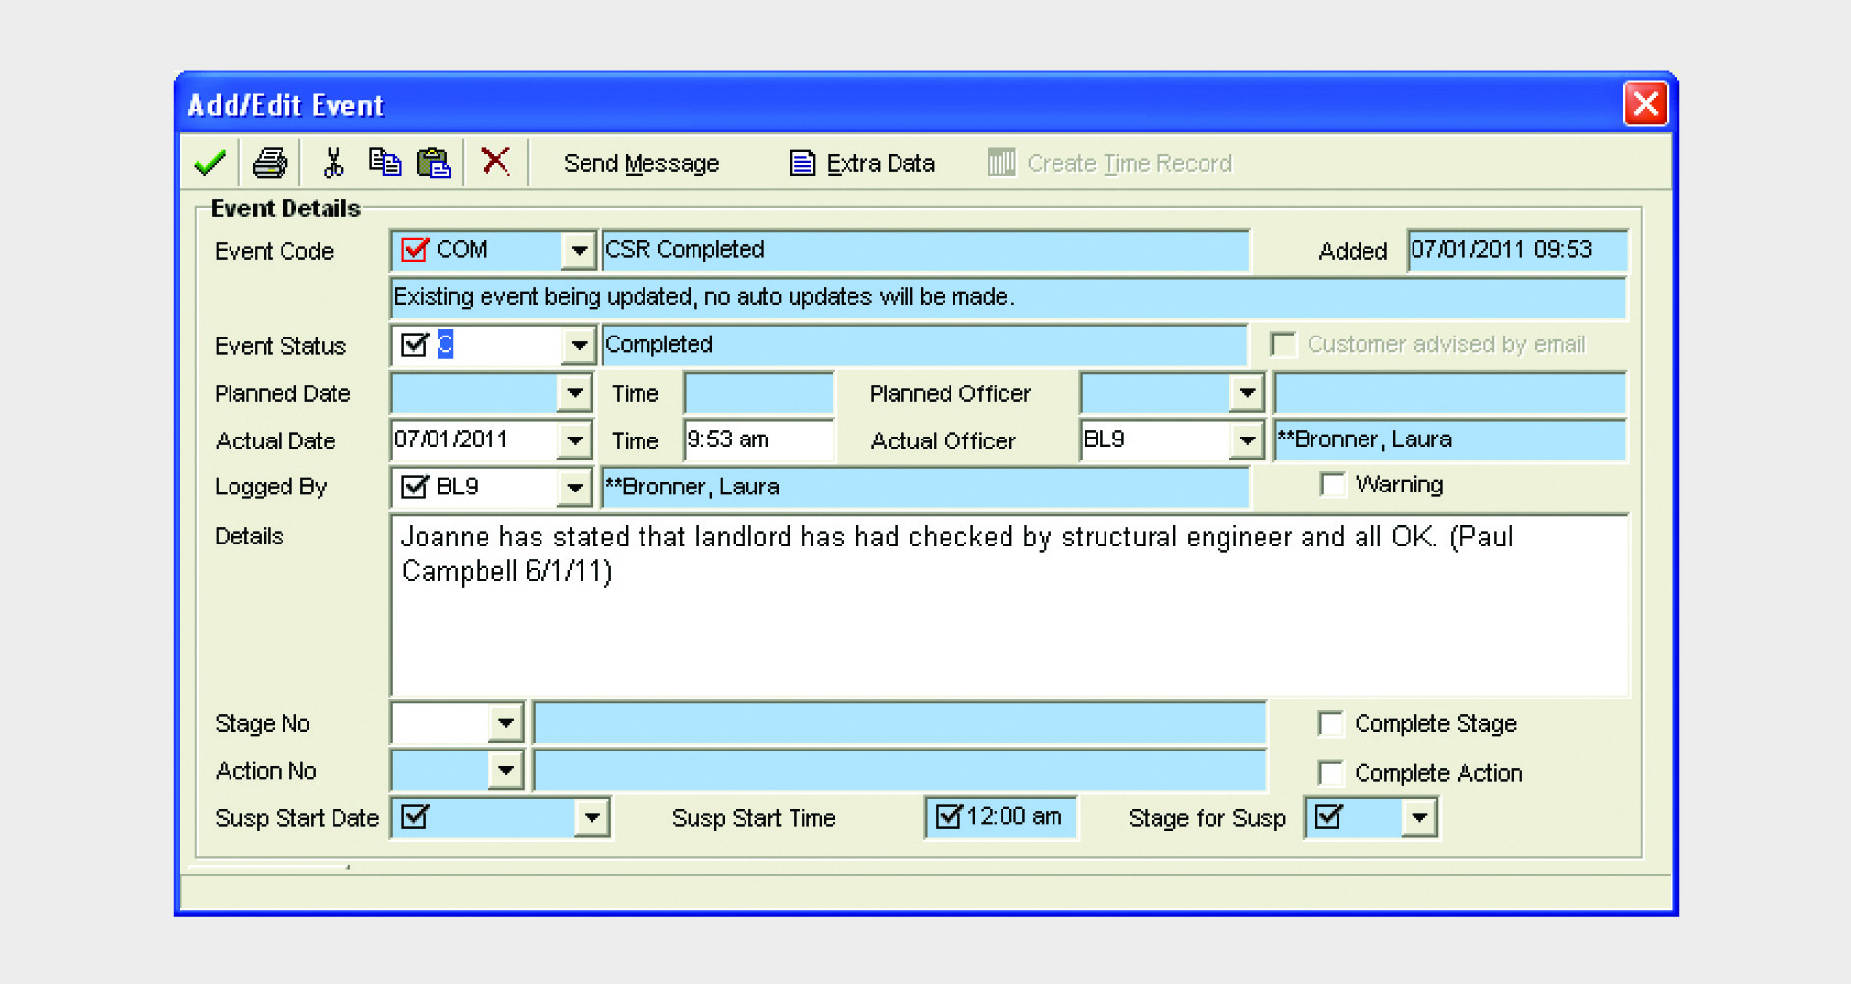

Figure 49: CCC computer record of Ms Vivian’s telephone call on 7 January 2011

There is a conflict between the evidence of Ms Vivian and that of Mr Drew about what was said during their telephone conversation. Ms Vivian said Mr Drew told her an engineer had been through the building after both September and Boxing Day. In an email on 1 March 2011 from Ms Vivian to her Chief Executive she recorded that Mr Drew had told her he had “already had the building inspected by his own engineers …” When that email was pointed out to her by counsel assisting she accepted it did not record Mr Drew telling her the inspection had been after Boxing Day. Mr Drew said that after Boxing Day he had relied on the CCC green placard, although he could not recall whether he mentioned this to Ms Vivian. He said he would have intended any reference to an engineer’s inspection to be either the post-September inspection or the CCC inspection that had been done after Boxing Day. The evidence does not allow any firm conclusion to be drawn about the actual content of the conversation.

3.6.7 Mr Drew’s actions after Boxing Day

The only additional visual damage reported to us which occurred after Boxing Day was about the column at level 6: given that would likely have been considered alongside other apparent damage, it is unlikely on this evidence alone that an engineer would have envisaged the limitations of the building. It may have triggered an examination of drawings but it is just as likely to have not raised alarm.

At the end of December Mr Drew noticed additional damage to the CTV building as a result of the Boxing Day aftershock. However he said that this was limited to some more broken windows and some cracks that had widened. He was asked in evidence about the cracks opening up and he said:

Well he had explained to me that’s just a normal part of the flexing. He expected that. He indicated that there was no concern basically.

These comments related to a discussion with
Mr Coatsworth before the Boxing Day aftershock. Apart from contacting CPG in January, Mr Drew did not take any steps to arrange an engineer’s assessment of the building after Boxing Day.

There had been difficulty in obtaining approval from
the insurers of the building to proceed with the repairs, however Mr Drew said that he was advised on 15 January 2011 that the building owners had agreed to proceed to have concrete contractors inspect the building and prepare quotes. He approached Concrete Protection and Repair Limited and Concrete Techniques Limited for this purpose.
3.6.7.1 Concrete Protection and Repair Limited

Mr Graeme Smith from Concrete Protection and Repair is a qualified civil engineer specialising in concrete repair since graduating in 1994. He visited the CTV building three times in early 2011. On his first visit he inspected the north wall complex and the south shear wall from the outside. On his second visit he met with Mr Drew and inspected both the inside and outside of the building. On his third visit the lifts were stopped and he inspected the inside of the lift shafts. He gave evidence that:

As a general comment, the cracking that I observed in the CTV building … was, in my experience, unremarkable and did not give me cause for concern... I can also say that the damage I observed in the CTV building was consistent with and did not appear to go beyond what was identified by Mr Coatsworth in the CPG report, namely fine hairline cracks.

Mr Smith prepared a quote for Mr Drew dated
22 February 2011.

3.6.7.2 Concrete Techniques Limited

Mr Drew contacted Concrete Techniques early in
2011 and asked them to provide an estimate of costs to repair cracking in various elements in the building. Mr Peter Higgins, the southern regional manager, made two visits to the CTV building in February 2011. The first visit was on 8 February, and as he had not seen the Coatsworth report, he considered the visit preliminary. Mr Drew identified typical damage, including column C18 outside the lifts on level 6.

Mr Higgins visited the building again on 14 February after he had reviewed the Coatsworth report. The purpose of this visit was to quantify the scope of works and he did not form any view about the nature of the damage that he observed. He prepared a quote for Mr Drew dated 15 February 2011. A photograph produced by him shows that there had been potentially significant additional damage following the Boxing Day aftershock to the east finger wall of the north wall complex where it extended to column C18. The top of column C18 was photographed by Mr Pagan as a part of the assessment of the building on 29 September and it is notable that his photograph did not extend to show the damage that has been circled by Mr Higgins in photograph A in Figure 50. It is likely that if this damage had been there in September then it would have been noticed and photographed by Mr Pagan.

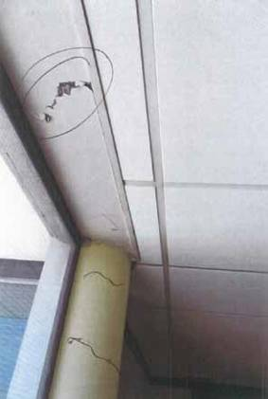

(a) Higgins

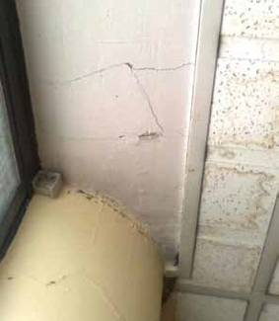

(b) Pagan

3.6.7.3 Assessment of Mr Drew’s actions after
Boxing Day

Mr Drew believed that the damage he saw on returning to the CTV building after the Boxing Day aftershock was not of significant concern. He assumed that the widening of the gaps in concrete was normal and expected. His confidence in the building was demonstrated by his willingness to occupy the building himself along with his wife and employees. Mr Drew must have been aware of the significance of the aftershock, as his Gloucester Street premises had been allocated a red placard as a result of it. Mr Drew was also aware of the limitations of the green placard on the CTV building, however he evidently continued to place some reliance on it. This was not a responsible position for him to take as the placard provided no guarantee of the safety of the building. Mr Drew was aware of tenants’ general concerns. He said in evidence:

This is all of course generally we’re having a range of aftershocks and everyone’s pretty nervous.
There was lots of conversations about earthquakes and buildings...

Although CPG was closed over the Christmas break, Mr Drew’s evidence was that he understood that they were opening on 9 January 2011 (in fact it was likely to be 10 January as the 9th was a Sunday). Mr Drew accepted in evidence that he could have obtained a
further engineer’s report. At the very least we consider that Mr Drew should have had a further conversation with Mr Coatsworth about the increased damage, as there was potential for the condition to be worse than he assumed. The best approach would have been to ask Mr Coatsworth to return to re-inspect the building as he had existing knowledge of the damage from the September earthquake.

Figure 50: Photographs of column C18 on level 6 outside the lifts taken by Mr Higgins on 14 February 2011 and Mr Pagan on 29 September 2010

3.7 Demolition of the neighbouring building

Evidence was given by a number of occupants of the CTV building of the concerns they had in the months following the September earthquake about the demolition of the building immediately to the west of the CTV building. In particular there was a general perception that the vibrations and shaking associated with the demolition work were having a detrimental effect on the structural integrity of the CTV building.

The demolition of the neighbouring building, 213 Cashel
Street, which was occupied by Injury Solutions, began in October 2010 and was completed approximately a week before the February earthquake. A two storey building to the west of that building at 207 Cashel Street was also demolished in this period.

This issue was explored in some detail at the hearing through witnesses’ descriptions of the effects of the demolition, evidence from the CCC as to the demolition application and its consideration of that application and expert opinion on whether it was likely the demolition could have affected the structure of the CTV building.

A number of those who worked in the CTV building believed that it was joined to the adjacent building at 213 Cashel Street because the two buildings were so close (approximately 150mm) and because of the effects they felt in their building when the adjacent wall of 213 Cashel Street was demolished. Ms Kulpe described a feeling of the CTV building being pulled when the adjacent wall was removed. She said it made the CTV building shudder. She thought that once the wall had been removed the CTV building felt weaker and would sway a lot more. Ms Aydon also described how it felt as if the wall had been “ripped away” from their building. Despite these observations, structural drawings show that the CTV building was not designed to be joined to the adjacent building and there was no evidence to suggest that it was joined in any way during or after construction.

Mr Malcolm Harris described the CTV building shaking constantly with the movement of the diggers. He said that when the wrecking ball was used the shaking was as severe as a large earthquake. He thought that in some ways the shaking from the demolition was worse than the aftershocks because it was continuous. From his observation the cracks along the western wall of the CTV building appeared to lengthen and widen once the demolition started.
Mr Fortune was in the process of installing cladding on the western wall of the CTV building on 22 February 2011 and described the effect on the CTV building when the wrecking ball was used to break up the foundations by dropping it from a height of about six metres. He said it felt like an earthquake. Other witnesses, including Ms Marie-Claire Brehaut and Ms Phillippa Lee, also described the constant shaking as a result of the demolition. Mr Brown, who worked for CTV until December 2010, said the CTV building was quite sensitive and would shake and shudder a lot as a result of the diggers and falling masonry, which caused a lot of anxiety among the staff.

3.7.1 Building consent

Herriot + Melhish: Architecture Ltd submitted an application to the CCC on 24 August 2010 for building consent to demolish the building at 213 Cashel Street and replace it with a car park. The site was immediately to the west of the CTV site. The processing of this application had been commenced but not completed at the time of the September earthquake.

The building consent for this work was approved for issue on 12 October 2010, and demolition was largely completed before the February earthquake. The neighbouring building to the west at 207 Cashel Street was also demolished as it was damaged by the September earthquake and following aftershocks. There is no record of a building consent for that demolition; however following the September earthquake demolition of buildings of this type were exempted from the requirement to obtain a building consent.

The demolition of the building at 213 Cashel Street was carried out by Frews Contracting Limited. The Methodology Statement approved by the demolition consent prescribed the use of a large digger. However, evidence given at the hearing described a wrecking ball was also employed. This shook the CTV building when it was dropped. Video evidence of the use of a large digger with a pincer attachment to pull down two storeys of brickwork was shown at the hearing. This was within the scope of the approved consent, but the wrecking ball was not.

3.7.2 Effect on the CTV building
A statement of evidence was provided from Mr William Dray, the civil engineer from the CCC who assessed the application for the building consent. He said:

…I did not consider that the demolition work as proposed would be capable of generating anything like the forces necessary to cause damage to any neighbouring building. The method proposed was that two large diggers would enter the buildings through the front and rear walls and merely pull back the side walls to enable loosened bricks to be collected and pallet stacked for re-use…

Dr Hyland and Mr Smith said in their report4 that it was, “unlikely that structural damage was caused by the demolition sufficient to affect the earthquake resistance of the CTV building”. The Expert Panel5 report concurred with this opinion, as did Mr Rob Jury when giving evidence during the hearing. Counsel for Dr Reay and ARCL also submitted that it is doubtful this work caused any damage to the building.

We also consider it unlikely that the demolition work caused damage to the CTV building, although the noise and vibrations were clearly disturbing to the occupants of the building.

3.8 The Clinic tenancy

The Clinic was a medical centre owned and run by Mr Drew and has wife. Before the Boxing Day earthquake it operated out of a building at
192 Gloucester Street. This building was allocated a red placard following the Boxing Day earthquake. During 2011 Mr Drew was in the process of buying an interest in Madras Equities Limited, which owned the CTV building, and was intending to relocate The Clinic into the building. He decided to bring forward the relocation and it was completed by 10 January 2011. The Clinic occupied level 5 of the building.

3.8.1 Change of use

Mr Drew gave evidence that he made a telephone
call to the CCC in May or June 2010 to enquire about whether he could move the medical centre into the CTV building. He said that as a result of this conversation he “wasn’t aware of any restrictions or authorities required”. For this reason, he did not notify the CCC before moving The Clinic into the building.

We heard some evidence and submissions about whether this relocation was a change of use under the Building Act 2004 and whether the CCC was required to approve it before occupancy commenced. If there was
a change of use, the CCC would have been required
by section 115(b) of the Act to consider whether the
A change in the use of a building is defined in clauses
5 and 6 of the Building (Specified Systems, Change the
Use, and Earthquake-prone Buildings) Regulations 2005:

5 Change the use: what it means

For the purposes of sections 114 and 115 of the Act, change the use, in relation to a building, means to change the use (determined in accordance with regulation 6) of all or a part of the building from one use (the old use) to another (the new use) and with the result that the requirements for compliance with the building code in relation to the new use are additional to, or more onerous than, the requirements for compliance with the building code in relation to the old use.
6 Uses of buildings for purposes of regulation 5

(1) For the purposes of regulation 5, every building or part of a building has a use specified in the table in Schedule 2.
(2) A building or part of a building has a use in column 1 of the table if (taking into account the primary group for whom it was constructed, and no other users of the building or part) the building or part is only or mainly a space, or it is a dwelling, of the kind described opposite that use in column 2 of the table.

The relevant part of Schedule 2 included:

Use Spaces or dwellings Examples

building complied with the Building Code provisions for (amongst other things) structural performance, as nearly as was reasonably practicable.

The CCC records indicate that before The Clinic occupied level 5, the floor had been used by Empower Rehabilitation as a physiotherapy clinic. The CCC’s position was that introduction of a medical clinic was not a change of use, even if the floor had been used as offices prior to The Clinic.
WL (Working Low)
spaces used for working, business, or storage—
low fire load1
…places for provision of personal or professional services, dental offices, laundries (self-service), medical offices, business or other offices, …

“Medical offices” are in the same category as “business or other offices”. For this reason, we agree that the introduction of The Clinic into level 5 of the building, or the physiotherapy clinic prior to that, did not amount to changes of use. There was no requirement to notify the CCC of the new tenancy unless work was to be undertaken that required building consent.

If Mr Drew had decided to alter the structure of level 5 of the building in some way to make it more suitable for the medical clinic, a building consent would have been required. Section 112(1) of the Building Act 2004 applies to alterations to existing buildings. This section requires the building consent authority to consider whether, after the alterations, the building will continue to comply with the Building Code “to at least the same extent as before the alteration”. Alterations to level 5 of the building are unlikely to have triggered a structural upgrade, but the issue does not arise because no such alterations were ever made.

If the building was considered to be earthquake-prone when an application for a building consent was lodged, the owner would have been required to comply with the CCC earthquake-prone buildings policy, which would have required some upgrading if the work was “significant”. The CCC earthquake-prone buildings policy is discussed in more detail in Volume 4 of this Report. However, the CTV building was not considered by the CCC to be earthquake-prone under the Building Act 2004. We agree that the building did not meet the definition of earthquake-prone under the Act.

For these reasons, Mr Drew was entitled to relocate The Clinic into the CTV building without making any application to the CCC, and the introduction of the tenancy did not constitute a change of use. Mr Drew would have been required to apply for a building consent before initiating any alterations.

Whether the building was suitable for use as a clinic without alteration or refurbishment is a concern of some bereaved families. That issue is not relevant to why the building failed and therefore outside the Royal Commission’s Terms of Reference.

References

1. NZS 1170.5:2004. Structural Design Actions, Part 5 – Earthquake Actions – New Zealand, Standards
New Zealand.

2. Bradley, B. (2012). Ground Motion and Seismicity Aspects of the 4 September 2010 and 22 February Earthquakes: Technical Paper prepared for the Canterbury Earthquakes Royal Commission. Christchurch, New Zealand: Canterbury Earthquakes Royal Commission.

3. New Zealand Society for Earthquake Engineering. (2009). Building Safety Evaluation During a State of Emergency: Guidelines for Territorial Authorities. Wellington, New Zealand: Author.

4. Hyland C., and Smith, A. (2012). CTV Collapse Investigation for Department of Building and Housing:
25 January 2012. Wellington, New Zealand: Department of Building and Housing.

5. Expert Panel Report: Structural Performance of Christchurch CBD Buildings in the 22 February 2011
Aftershock. (2012). Report of an expert panel appointed by the Department of Building and Housing. Wellington, New Zealand: Department of Building and Housing.

Note: Standards New Zealand was previously known as the Standards Association of New Zealand and the Standards
Institute of New Zealand

